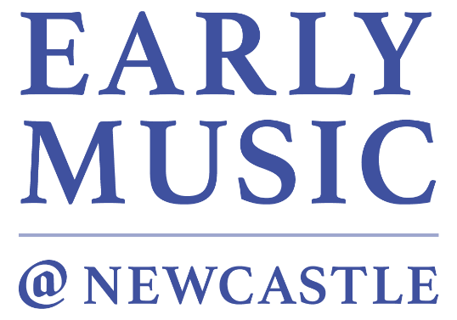

Thursday 1st April, 1.15pm

NEWCASTLE UPON TYNE BACH CHOIR
ERIC CROSS (conductor)

O magnum mysterium Tomás Luis de Victoria (1548-1611)

Dixit Maria Hans Leo Hassler (1564-1612)

Resonet in laudibus Jacob Handl (1550-91)

Quem vidistis, pastores? Richard Dering (c.1580-1630)

Lobet den Herrn, alle Heiden, BWV 230 J.S. Bach (1685-1750)

Kyrie in A major & Heilig Felix Mendelssohn-Bartholdy (1809-47)

O Radiant Dawn James MacMillan (b. 1959)

Texts & Translations

O magnum mysterium  O magnum mysterium et admirabile sacramentum, ut animalia viderent  Dominum natum jacentem in praesepio.  O beata Virgo, cuius viscera meruerunt portare Dominum Jesum Christum.  Alleluia. | O great mystery and wonderful sacrament, that beasts should see the new-born Lord lying in a manger.  O blessed virgin, whose body was worthy to bear the Lord Jesus Christ.  Alleluia.
Dixit Maria  Dixit Maria ad angelum:  Ecce ancilla Domini,  fiat mihi secundum verbum tuum. | Mary said to the Angel:  Behold, I am the handmaid of the Lord,  let it be done to me, according to your word.
Resonet in laudibus  Resonet in laudibus  cum jucundis plausibus  Sion cum fidelibus:  apparuit quem genuit Maria.  Sunt impleta quae predixit Gabriel.  Eya, eya, Virgo Deum genuit  quod divina voluit clementia.  Hodie apparuit in Israel:  Ex Maria Virgine est natus Rex. | Let praises resound  with joyous acclaim:  To Sion’s faithful  the child born of Mary has appeared.  Gabriel’s prophecies have been fulfilled:  O joy! A Virgin has given birth to God,  as divine mercy willed it to be.  Today he has appeared in Israel: a King is born of the Virgin Mary.
Quem vidistis, pastores?  Quem vidistis, pastores? Dicite: et annuntiate nobis in terris quis apparuit? Natum vidimus, et choros angelorum, collaudantes Dominum.  Alleluia. | Who have you seen, shepherds? Speak: and tell us who has appeared on earth? We have seen the new-born child and a chorus of angels praising the Lord. Alleluia.
Lobet den Herrn, alle Heiden  Lobet den Herrn, alle Heiden,  und preiset ihn, alle Völker!  Denn seine Gnade und Wahrheit  waltet über uns in Ewigkeit.  Alleluia. | Praise the Lord, all the heathens  And celebrate him, all the nations!  For his grace and truth  Reign over us for ever.  Alleluia !
Kyrie  Kyrie eleison, Christe eleison, Kyrie eleison. | Lord have mercy, Christ have mercy, Lord have mercy.
Heilig  Heilig, heilig, heilig, ist Gott, der Herr Zebaoth!  Alle Lande sind seiner Ehre voll.  Hosianna in der Höh’!  Gelobt sei, der da kommt im Namen des Herrn!  Hosianna in der Höh’! | Holy, holy, holy, Lord God of hosts!  Every nation proclaims his glorious praise.  Hosanna in the highest.  Blessed is he who comes in the name of the Lord.  Hosanna in the highest.
O Radiant Dawn

O Radiant Dawn, Splendour of eternal Light, Sun of Justice:
come, shine on those who dwell in darkness and the shadow of death.

Isaiah had prophesied,
The people who walked in darkness have seen the great light
upon those who dwelt in the land of gloom a light has shone.
Amen.

The Newcastle Bach Choir is hugely grateful to John Paul Hardy, who has assembled this concert from over 300 individual recordings. It would have been impossible without his tireless efforts.

LIVE Concerts at Home continues after Easter, on Thursday 29th April. Hannabiell Sanders and Yilis Suriel, from Ladies of Midnight Blue, present an Afro-Latin percussion and brass duet. The concert recording will be available via the ICMuS YouTube channel; https://www.youtube.com/c/musicnewcastleuniversity
Early Music @ Newcastle podcasts are still available. Please visit the direct YouTube links as follows:
Russell Gilmour: https://www.youtube.com/watch?v=bw6XR-PfLVY
Adrian France: https://www.youtube.com/watch?v=F-XWPAZR7nQ
Mhairi Lawson (1): https://youtu.be/i_KV4shVaj8
Ensemble Pro Victoria in rehearsal: https://youtu.be/ZJko6P2Jjlg
Kirsten Gibson and Stephanie Carter: https://youtu.be/nK5K9aKkbN4
Roz Southey: https://youtu.be/0IRv_WTCWsk
Magnus Williamson: https://youtu.be/neWitNBhKyo
Andrew Cantrill-Fenwick: https://youtu.be/A25o8ao7C2c
Mhairi Lawson (2): https://youtu.be/fD3uaFIe4o0
Larry Zazzo and Geoff Page: https://youtu.be/KRdnRgCgqJg
Eric Cross & Newcastle Bach Choir: https://youtu.be/UYVUwr95zDo
Magnus Williamson on Robert Fayrfax: https://youtu.be/sfjQUZ4uCuQ

And yesterday’s concert (Magdalena Loth-Hill and John Green): https://youtu.be/GBhqsWT6kts

On Wednesday 5th May Professor Kate van Orden presents 'Songs in Unexpected Places: Language and Mobility in Sixteenth-Century Europe' as a Research Seminar. This will take place via Zoom. The link to sign up to attend this free Seminar will be posted on the King’s Hall website nearer the time.

https://www.facebook.com/earlymusicatnewcastle
https://twitter.com/earlymusicncl
To sign up to the Friends of King's Hall mailing list to receive information about upcoming concerts (via email), please go to: www.ncl.ac.uk/events/live-music/mailing-list

