UNESCO BILKO RESOURCE BOOK

An Index to Computer Based Learning Modules in Remote Sensing of Coastal-Marine Environment

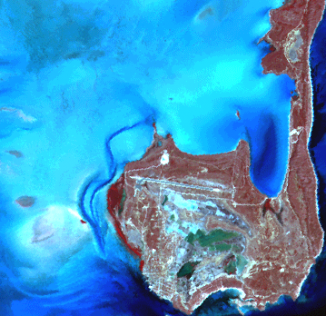

R. Sudarshana, D. Mitra, A. K. Mishra
(Assistance from Joydas T V and Bilal Ahmad Wani)

Marine Science Division
Indian Institute of Remote Sensing
(National Remote Sensing Agency)
Department of Space
Government of India
4-Kalidas Road
Dehradun, UP – 248 001

March, 2000

Foreword

Remote sensing applications to coastal management is a very important activity that has gained enormous momentum in the recent past. There is an increased effort within many national and international organisations to address this necessity and develop an expert capacity. One such coveted effort is of UNESCO-CSI towards developing computer based learning modules on the subject. In the last 10 years, nearly 50 lessons by way of 7 modules have been produced and distributed. The Marine Science Division of IIRS has also been very actively involved in the process at various stages and in various dimensions.

The present effort is intended to bring out a guide book or a resource book that could summarise and categorise all the lessons of 7 modules in order to provide a brief, concise and correct introduction to remote sensing applications in coastal – marine environment. The work is done at two levels. Firstly, a manual is prepared as hard copy to provide a ready reference. Secondly the entire material is digitally produced with proper hyperlinking, so that index based browsing and learning could be accomplished.

This is only a draft document and needs further improvement, especially to involve the concept of online linking with the home site and mirror sites of the original lessons.

Sl. No: | Contents |  | Page No
 | Foreword |  | iii
 | Contents |  | v
 | Schemes of Classification |  | 1
 | Index.1: Geographical Classification: General |  | 3
 | Index.2: Geographical Classification : Pacific Ocean |  | 4
 | Index.3: Geographical Classification : Atlantic Ocean |  | 5
 | Index.4: Geographical Classification : Indian Ocean |  | 6
 | Index.5: Geographical Classification: Southern Ocean |  | 7
 | Index.6: Geographical Classification : Global Ocean |  | 8
 | Index. 7: Thematic Classification: General |  | 9
 | Index. 8: Thematic Classification: Coastal Management |  | 10
 | Index. 9: Thematic Classification: Open Ocean Environment |  | 11
 | Index.10: Thematic Classification: Simulation |  | 12
 | Index.11: Data Classification: General |  | 13
 | Index.12: Data Classification: Optical and Infra-red Sensors |  | 14
 | Index.13: Data Classification: Microwave Sensors |  | 15
 | Index.14: Data Classification: Airborne Sensors/ In Situ |  | 16
 | Index. 15: Data Classification: Numerical Modeling |  | 17
 | Summaries of Lessons |  | 19
 | Module 1
1. | Images of Open Ocean Sea-Surface Temperature. |  | 22
2. | Thermal Images of Ocean Fronts. |  | 24
3. | Coastal Zone Colour Scanner Data off Iceland. |  | 26
4. | Comparison of Coincident AVHRR and CZCS Data. |  | 28

Sl. No: | Contents |  | Page No
5. | Shelf Sea Thermal Structure 1 – North Sea, Early  Summer. |  | 30
6. | Shelf Sea Thermal Structure 2 – Early Summer Stratification in the Irish Sea. |  | 32
7. | Oceanographic Interpretation of Images: Airborne TM data – Southampton Docks. |  | 34
 | Module 2
8. | Analysis of a Synthetic Aperture Radar Image of the Straits of Dover. |  | 38
9. | Seasonal Variation of Phytoplankton distribution in the Arabian Sea. |  | 40
10. | Studies of South American Coastal Discharge Using Landsat Data. |  | 42
11. | Display and Analysis of Acoustic Doppler Current Profiler (ADCP) Data. |  | 44
12. | Wind-driven Upwelling off the Coast of South Australia. |  | 46
13. | Thermal Structure of the Southern Coral Sea. |  | 48
 | Module 3
14. | Extent and Content Differentiation of Coastal Plumes. |  | 52
15. | Using Landsat for Coastal Management – 1: Mapping and Determining Major Substrate Categories. |  | 54
16. | Using Landsat for Coastal Management - 2: Vegetation Mapping. |  | 56
17. | Detection of Potential Areas for Coastal Aquaculture using the Indian Remote Sensing Satellite - IRS 1A. |  | 58
18. | Study of Coastal Lagoonal Features Using IRS – 1A LISS Data. |  | 60
19 | Temporal and Spatial Variations in Sea-ice Concentration in the Southern Ocean. |  | 62
20. | Global Waves and Winds from Geosat. |  | 64
21. | Ocean Eddy Dynamics Generated by a Numerical Model. |  | 66

Sl. No: | Contents |  | Page No
 | Module 4
22. | Imaging in-situ Bio-optical and Physical Parameters. |  | 70
23. | Spatio-temporal Evolution of Coastal Upwelling in the Senegalese Mauritanian Littoral. |  | 72
24 | Variation of AVHRR-derived Sea Surface Temperature with the Satellite zenith angle. |  | 74
25. | Seasonal and Yearly Variation of Surface-temperature Distributions in the North Sea. |  | 76
26. | Analysis of Turbid Plume of the Gironde Estuary (France) using SPOT Data. |  | 78
27. | Detection of Sea-surface Life with an Airborne Synthetic Aperture Radar. |  | 80
28. | Bathymetry Prediction from Satellite Altimeter Data |  | 82
 | Module 5
29. | Identification and Differentiation of Coastal Ecosystems. |  | 86
30. | Principal Characteristics of the Area around Lagartos River, Yucatan, Mexico. |  | 88
31. | Evolution of Coastal Upwelling Event at 30°S. |  | 90
32. | Observation and Analysis of a Red Tide Event from NOAA/AVHRR Images in the Argentinean Sea. |  | 92
33. | Research on Physiographic Phenomena influenced by Marine Currents in the Terminos Lagoon. |  | 94
34. | Thermal Structures Associated with the Superficial Calculation Observed Between Cape Verde and Freetown (North West Africa). |  | 96
35. | Monitoring the Coastal Upwelling NW of Africa with AVHRR-APT Images. |  | 98
36. | Study of the Distribution of Suspended Solids in the Western Coast of Maracaibo Lake (Venezuela), Using Landsat Data. |  | 100
37. | Identification of Physical Processes Favouring the Development of Phytoplankton, Based on the Colour Characteristics of the Sea. |  | 102

Sl. No: | Contents |  | Page No
 | Module 6
38. | Deriving Sea Surface Temperature Maps from the ERS-1 Along Track Scanning Radiometer (ATSR). |  | 106
39. | Using Landsat for Coastal Management-1: Mapping and Determining Major Substrate Categories. |  | 108
40. | Using Landsat for Coastal Management-2: Vegetation Mapping. |  | 110
41. | Imaging Coastal Features with ERS-1 Synthetic Aperture Radar (SAR); Central English Channel. |  | 112
 | Module 7
42. | Visual Interpretation of Images with the Help of Colour Composites: Getting to Know the Study Area. |  | 116
43. | The Importance of Acquiring Images of the Appropriate Scale and Spatial Resolution of your Objectives. |  | 118
44. | Radiometric Correction of Satellite Images: When and Why Radiometric Correction is Necessary. |  | 120
45. | Crude Bathymetric Mapping Using Landsat TM Satellite Imagery. |  | 122
46. | Compensating for Variable Water Depth to Improve Mapping of Underwater Habitats: Why it is Necessary. |  | 124
47. | Mapping the Major Inshore Marine Habitats of the Caicos Bank by Multispectral Classification Using Landsat TM. |  | 126
48. | Predicting Seagrass Standing Crop from SPOT XS Satellite Imagery. |  | 128
49. | Assessing Mangrove Leaf Area Index (LAI) Using CASI Airborne Imagery. |  | 130

Schemes of Classification

Index.1: Geographical classification: General

Geographical Classification

Pacific
Ocean

Atlantic Ocean
Global Ocean

Indian Ocean
Southern Ocean

M2L5
M2L6
M4L7
M5L3

M1L1 M1L2
M1L3 M1L4 M1L5 M1L6 M1L7 M2L1 M2L3 M4L1 M4L2 M4L4 M4L5 M4L6 M5L1 M5L2 M5L4 M5L5 M5L6 M5L7 M5L8 M5L9 M6L4 M7L1 M7L2 M7L3 M7L4 M7L5 M7L6 M7L7 M7L8
M2L2 M2L4 M3L1 M3L2 M3L3 M3L4 M3L5 M4L3 M6L1 M6L2 M6L3
M3L6
M3L7M3L8

Notation used: M = Module and L = lesson

Index.2: Geographical classification: Pacific Ocean

Pacific Ocean

South West

South East
Pacific Antarctic Ridge

M4L7

Australia

Chile Coast

M2L5
M5L3

Coral Sea

M2L6

Index.3: Geographical classification: Atlantic Ocean

Atlantic Ocean

North

West

East

South

North East

Lagartose

Brazil

West Africa

English Channel

Senegalese
M5L2
M2L3 M5L1

M6L4

Venezuela

South West
M4L2

Norway Sea
M5L8

Argentina

North West Africa
M1L1

Caribbean Sea
M5L4
M5L6, M5L7

Off Iceland
M5L9

M1L2, M1L3 M1L4

Gulf of Mexico

North Sea
M5L5

M1L5, M4L4 M2L1

Irish Sea

Southampton
M1L6

M1L7

Turks and Caicos

Gironde Estuary
M7L1M7L2 M7L3 M7L4 M7L5M7L6 M7L7M7L8
M4L5

Mediterranean Sea

M4L6

North West

Sargasso Sea

M4L1

Index.4: Geographical classification: Indian Ocean

Indian Ocean

Arabian Sea

Bay of Bengal

Red Sea

Malaysia Off

Chilka Lake
M2L2, M2L4,
M3L4
M3L2, M3L3, M6L2, M6L3
M3L1

M3L5

West Indian Ocean

North East

M4L3
West Coast of Japan

M6L1

Index.5:Geographical Classification: Southern Ocean

Southern Ocean

M3L6

Index.6: Geographical classification: Global Ocean

Global Ocean

M3L7 M3L8

Index.7: Thematic Classification: General

Thematic Classification

Coastal Management

Open Ocean Environment

Simulation

M1L3 M1L4 M1L5 M1L6 M1L7 M2L1 M2L2 M2L3 M2L5 M2L6 M3L1 M3L2 M3L3 M3L4 M3L5M4L1 M4L2 M4L4 M4L5 M5L1 M5L2 M5L3 M5L4 M5L5 M5L6 M5L7 M5L8 M5L9 M6L1 M6L2 M6L3 M7L1 M7L2 M7L4 M7L5 M7L6 M7L7M7L8
M1L1 M1L2 M2L4 M3L6 M3L7 M3L8 M4L6 M4L7
M4L3 M3L8 M7L3

Index.8: Thematic classification: Coastal Management
( Since some lessons belong to more than one theme they are included in all the themes they belong to)

Coastal Management

Physical Processes
Suspended Load

Vegetation
Habitat
Up- welling

SST

M1L4 M1L6 M2L5 M2L6M4L1 M4L2M4L4M5L4 M5L6
M6L1
M3L3 M3L5 M4L1 M5L1 M5L2 M6L3 M7L1 M7L2 M7L7 M7L8
M3L2M6L2 M7L1 M7L2 M7L6
Currents
M1L3
M1L5
M2L3
M3L1
M4L5 M5L8

M2L5 M4L2 M5L3 M5L6 M5L7

M4L1M5L5

Waves

M2L1

Aqua- culture

Phyto- plankton

Bathymetry

Harbour

Surface features

M2L3M5L5M7L4M7L5
M1L7
M3L4
M2L2M5L4M5L9
M1L7 M6L4

Index.9: Thematic classification: Open ocean environment

Open Ocean Environment

SST

Currents

Wind

Bathymetry

Waves

M1L1M1L2
M1L1 M2L4
M3L7
M3L7
M4L7

Sea Ice

Sea Life

M3L6
M4L6

Index.10: Thematic classification: Simulation

Simulation

Radiometric correction
Correction of error induced by satellite zenith angle

Current

M3L8
M7L3
M4L3

Index.11: Data Classification: General

Data Classification

Optical & Infra-red Sensors
Airborne Sensors/ In situ
Micro-wave Sensors
Numerical Modelling

NOAA, LANDSAT, SPOT, IRS & METEOSAT
GEOSAT, SEASAT, ERS & DMSP
CASI, Daedalus- 1268, ADCP & MVMS
Computer Ocean Model
M1L1 M1L2 M1L3 M1L4 M1L5 M1L6 M2L2 M2L3M2L5 M2L6 M3L1 M3L2M3L3 M3L4 M3L5 M4L2 M4L3 M4L4 M4L5M5L1 M5L2M5L3 M5L4 M5L5M5L6 M5L7 M5L8M5L9 M6L2 M6L3 M7L1M7L2 M7L3 M7L4 M7L6 M7L7
M3L8
M1L7 M2L4 M7L2 M7L5 M7L8
M2L1 M3L6 M3L7 M4L6M4L7 M6L1 M6L4

Index.12: Data Classification: Optical and Infra-red Sensors

Optical and Infra-red Sensors

NOAA

LANDSAT

SPOT

IRS-1A

METEOSAT

AVHRR

TM

XS

LISS-1

METEOSAT IR

M1L1 M1L2 M1L4 M1L5 M1L6 M2L5 M2L6 M4L3 M4L4 M5L3 M5L4 M5L6 M5L7
M2L3 M3/L1 M3L2 M3L3 M5L1 M5L5 M5L8 M6L2 M6L3 M7L2 M7L3 M7L4 M7L6
M4L5 M7L1 M7L2 M7L7
M3L4 M3L5
M4L2

LISS-2

PAN
M3L4 M3L5

M7L2

CZCS

MSS

M1L3 M1L4 M2L2 M5L9
M3L4 M3L5 M5L2 M7L2

Index.13: Data Classification: Microwave Sensors

Microwave Sensors

GEOSAT

SEASAT

ERS

DMSP

Altimeter

SAR

SAR

SSM/I

M3L7 M4L7
M2L1
M4L6
M6L4
M3L6

Index.14: Data Classification: Airborne Sensors/ In situ

Airborne Sensors/ In Situ

Airborne Sensors

In Situ

CASI

ADCP

M7L1M7L2 M7L5 M7L8
M2L4

MVMS

Daedalus 1268
M4L1

M1L7

Index.15: Data Classification: Numerical Modeling

Numerical Modeling

Computer Ocean Model

M3L8

Summaries of Lessons

Module: 1

Lesson title: Images of Open Ocean Sea-Surface Temperature
Module No. /Lesson No: M1/L1

Data key: AVHRR NOAA
Location: North-East Atlantic Ocean
Classification key: SST, open ocean environment
Connectivity: M1L2 & M2L4

Aim: To provide experience in the interpretation of sea-surface temperature images based on infra-red data form NOAA AVHRR sensor, and demonstrate the oceanographic opportunities and limitation of such data for the study of thermal structure of the open ocean.

Location and Data: Study area is the North Atlantic Ocean in the region between Norway and Scotland.
Three infra-red images of NOAA AVHRR are used. These three images are northward continuation of the image.

Procedure: Images may be displayed with suitable palette. Stretching can be performed to improve the image until it reveals patterns of SST structure. Area having higher or lower temperatures and trend of temperature across the image can also be extracted. Identification of mesoscale features present on the image can also be made.

Result: The northward warm water flow from the Atlantic in to Norwegian Sea is found in the western part of the image. The cooler Norwegian Coastal current can be found at the eastern edge of the image. The meanders of the Norwegian Coastal current appear to have a typical length scale of about 30 pixels, equivalent to a true length scale of 28 km. The temperature change across the front is 1.2 C. The eddy features have a temperature difference between centre and outside of about 0.5 C and a diameter of approximately 22 pixels (20 km)

Schematic Representation of the lesson:

Display of the images
Step I

Stretching of the image

Step II

Interpretation of the image
Step III

Warmer current from Atlantic to Norwegian Sea and the cooler Norwegian Current are observed
Result

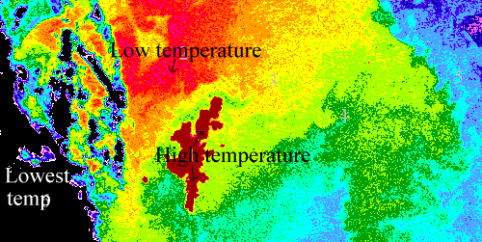
Representative images of the lesson:
AVHRR NOAA image shows SST

Lesson title: Thermal Images of Ocean Fronts
Module No. /Lesson No: M1/L2

Data key: AVHRR NOAA
Location: Off Iceland
Classification key: SST, open ocean environment
Connectivity: M1L1

Aim: To provide experience in the interpretation of sea surface temperature images based on infra red data from the NOAA AVHRR sensor, demonstrating the oceanographic opportunities and limitations of such data for the study of ocean fronts.

Location and data: The study area is the North East Atlantic Ocean in the region of Iceland. Two versions of a single IR image data set from an over pass of the AVHRR on NAOO-6 polar orbiting meteorological satellite are used for the study.

Procedure: Images may be displayed after stretching. Temperature range across the image can be found out and the position of the Iceland may be located. Histogram can be prepared and two peaks may be noted. Interpretation can be made on the temperature field and may be related to the known physical oceanography of the region. It may be possible to prepare several transect in north south direction to display the temperature profile across the front. Gradient option may be used to highlight the position of the front and that of other regions of thermal gradients. To improve the look, smooth filtering can also be performed.

Result: Twin peaks in the temperature histogram are visible and it is due to the fact that the front is so sharp that very few pixels have temperatures intermediate between two. Cool peak is small because cool water acquires a small area than the warmer water to the south. It is found that the quality of the data is degenerated by smoothing. Its most degrading effect is found at the frontal boundary where it weakens the horizontal temperature gradient and at coast or at cloud boundaries, which it smears.

Schematic Representation of the lesson:

Display of the images
Step I

Stretching of the image

Step II

Preparation of histogram
Step III

Step IV

Preparation of transect and application of smooth filter

Step V

Interpretation of image

Cold water occupies a small area than the warmer water to the south
Result

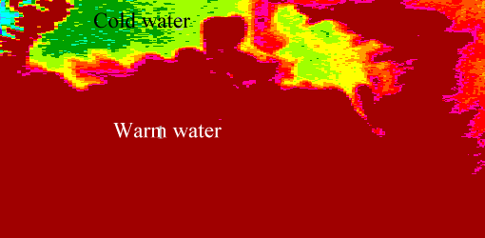
Representative image of the lesson:
AVHRR NOAA image shows SST

Lesson title: Coastal Zone Colour Scanner Data off Iceland
Module No. /Lesson No: M1/L3

Data key: CZCS of Nimbus - 7
Location: Off Iceland
Classification key: Suspended load, coastal management
Connectivity: M1L5, M3L1, M2L3, M4L5 & M5L8

Aim: To provide experience in the interpretation of multichannel ocean colour images based on visible wavelength data from the Nimbus – 7 CZCS sensor, and to demonstrate some of the oceanographic applications of such data, in the coastal region and in the vicinity of an Oceanic Front.

Location and Data: Off Iceland is the study area. 1- 4 channels of CZCS from a single overpass of the Nimbus – 7 satellite are utilized for the study.

Procedure: Images of the four channels may be displayed. Stretching can be done to improve the image until it reveals the patterns of the radiance structure in the water. Area having higher or lower radiance can be identified. Comparison can be made for the images of four channels. Interpretation can be conducted with the available oceanographic factors. Two-band ratioing of channel 1 and 3 can be made for revealing the underlying patterns due to chlorophyll absorption. The gradient function can be performed in each image to identify where the features are strongest. An investigation can be conducted using ocean colour remote sensing to find out the oceanographic features of the region.

Result: Analysis of the two-band ratio confirmed the signature of an optically scattering material, which could be either Coccolithophore bloom or suspended sediments. Given the apparent origin of the reflective material near the coast of Iceland, the suspended sediment seems the most likely, with glacial melt water sediments being washed in to the sea from Iceland rivers.

The high reflectance tell which might not be readily be apparent from conventional local oceanographic measurements is that the plume of material is being carried off-shore along the line of the Iceland – Faroes Front.

Schematic Representation of the lesson:

Display of the images
Step I

Stretching of the image
Step II

Comparison of the images of four channels
Step III

Step IV

Interpretation of data

Result

A plume of material is being carried offshore along the line of the Iceland – Faroes Front

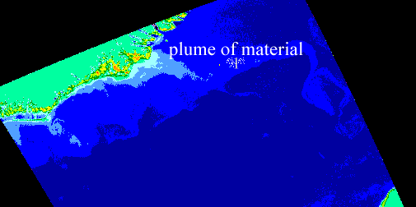
Representative image of the lesson:

Two band ratio of CZCS Nimbus-7 image of band 3 and 1 showing plume of material is being carried off shore along the line of the Iceland – Faroes Front

Lesson title: Comparison of Coincident AVHRR and CZCS Data
Module No. /Lesson No: M1/L4

Data key: CZCS Nimbus – 7 and AVHRR NOAA
Location: Iceland
Classification key: SST, coastal management
Connectivity: M1L6, M2L6, M4L1, M4L2, M4L4, M5L4, M5L6 & M6L1.

Aim: To provide experiences in the interpretation of multi sensor ocean images comprising visible wavelength data from the Nimbus – 7 CZCS sensor, and infra red data from the AVHRR sensor; and to explore the oceanographic applications of the combined data set.

Location and Data: The study area is the Iceland. Five images are used for this study and 4 are based on data from bands 1-4 of CZCS and 5th is a SST of map derived using the AVHRR channel 4 on the NOAA 6 satellite.

Procedure: Image may be displayed and different parts like land, sea and cloud can be identified. Stretching can be conducted for this. At least one ground control point can be located on the each image and from its pixel coordinates evaluation can be conducted for its latitude and longitude. Comparison between predicted location and true location on the chart can be made. A correction factor can be applied to each image to fix the geographic location of a pixel accurately. Location of the Iceland Faroes Front from this infra-red image of AVHRR can be found out. The position of the high reflectance plume from CZCS images can also be seen. Investigation can be made to obtain oceanographic information with reference to frontal region by considering both colour and infra-red data together.

Result: Land sea contrast in channel 4 shows better than other bands because light at 670nm is more readily absorbed by the sea than shorter wavelength. The colour plume appears to be drawn out along the thermal front. Transect across the front shows the highest reflectance at the steepest part of the thermal front. This is to be expected from the dynamical consideration, since a strong geostrophic flow is to be expected along the front and this flow must be advecting the optically reflective material, which it has collected from the Iceland Coastal area. The colour imagery thus provides evidenced of flow, which can only be inferred dynamically from the thermal image.

There is strictly no connection between the magnitude of the visible reflectance and the temperature of corresponding pixels. Low reflectance is found in high and low temperature region. However it is when the spatial patterns of the two types of images are compared that the interdependence of the interpretation of the two images becomes apparent.

Schematic Representation of the lesson:

Display of the images with stretch
Step I

Fixing geographic location of pixel

Step II

Step III

Mapping of plume from CZCS image

Step IV

Correlation of colour and thermal pattern

Colour imagery provides evidence of geostrophic flow, which is inferred dynamically from the thermal image
Result

Representative image of the lesson:
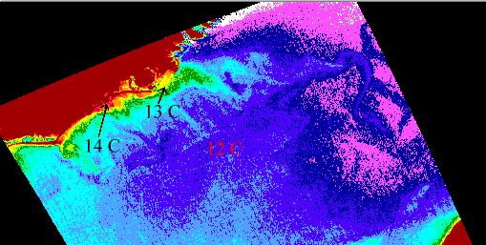
CZCS AVHRR image shows SST

Lesson title: Shelf Seas Thermal Structure 1 – North Sea, Early Summer
Module No. /Lesson No: M1/L5

Data key: AVHRR /2 NOAA - 7
Location: North Sea
Classification key: Suspended load, coastal management
Connectivity: M1L3, M3L1, M2L3, M4L5 & M5L8

Aim: To provide experience in the analysis and interpretation of sea surface temperature images of a typical shallow sea when coastal discharges have a contrasting temperature.

Location and Data: The study area is the North Sea. Three SST images from channel 4 & 5 of the AVHRR/2 sensor on the NOAA 7 satellite are used for the study.

Procedure: The night and daytime images of 24-04-1984 may be displayed. Land, sea and cloud parts may be distinguished using suitable stretch and prominent features may also be visualized. The spatial extent and the size of the thermal structure of prominent features can be estimated. A contour map of SST may be made using linear stretch. The two images may be compared for overall temperature levels. The temperature of the features related to the surrounding may also be compared. The third image of 28-4-1985 may be displayed with suitable stretch and may be compared with previous image. The thermal structure of the North Sea detected from the image may be used to suggest the possible residual flow patterns occurring in the sea and insights may be gained about the dispersal of materials in the region.

Result: Prominent features like, a warm patch off the North Yorkshire Coast, plume of water discharging from the River Thames, fringe of warm coastal water along the Belgian Coast and discharge from the River Rhine are observed in the images. Land is shown cooler than sea in the nighttime image. The nighttime image appears to be overall a few tenths of a degree C lower in temperature than the daytime image. This may be due to the absence of a diurnal thermocline at night.

The warmer water discharged by the rivers provides a non-conservative tracer of river plume assimilation in to the wider North Sea. There appear to be southward trending coastal flow down the northeast English Coast, but northward flow carrying the Rhine discharge along the Dutch Coast. The discharged water plumes appear to remain coherent and poorly dispersed.

Schematic Representation of the lesson:

Display of the images
Step I

Comparison of the images for thermal structures
Step II

Detection of prominent features
Step III

Prominent features like, plume of water discharging from the River Thames, fringe of warm coastal water along the Belgian Coast and discharge from the River Rhine are observed in the images.
Result

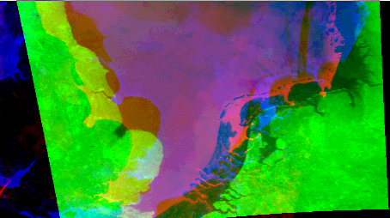
Representative image of the lesson:

AVHRR NOAA image shows SST

Lesson title: Shelf Seas Thermal Structure 2- Early Summer Stratification in the Irish Sea
Module No. /Lesson No: M1/L6

Data key: AVHRR/2 NOAA-7
Location: Irish Sea,
Classification key: SST, coastal management
Connectivity: M1L4, M2L6, M4L1, M4L2, M4L4, M5L4, M5L6 & M6L1

Aim: To provide experience in the analysis and interpretation of SST images of a shelf sea during the onset of thermal stratification in late spring/early summer.

Location and Data: The Irish Sea and West Atlantic off the coast of Ireland is the study area. Four SST images from channels 4 & 5 of the AVHRR/2 sensor on the NOAA 7 Satellite are used in the study.

Procedure: Day and night time images of 24-04-1984 may be displayed. Using suitable stretch, colour contour map of SST and temperature range encountered within the sea on both the images can be determined. Thermal features on both the images may be identified and both the images may be compared. Day and night images of 26-04-1984 may also be displayed. Applying stretch thermal structure and overall sea temperature range can be identified and compared with previous day and night time images. Thermal fronts in both this images may also be identified and compared.

Result: There is evidence from the sequence of the images of the development of the seasonal stratification west of the Isle of Man, and the associated front between stratified and unstratified water. The warm plumes, which appear to start at the headlands and curve gradually round in to the Atlantic Ocean, are probably manifestations of a diurnal thermocline effect. The warm streaks appear to line up with the wind direction. Presumably the headlands are creating a windbreak behind which the wind is sufficiently weakened to permit the diurnal thermocline to form, where as in other regions it is destroyed by wind mixing.

Schematic Representation of the lesson:

Display of the images
Step I

Identification of thermal structures

Step II

Comparison of images
Step III

Result

There is evidence from the sequence of the images of the development of the seasonal stratification in the west of the Isle of Man

Representative images of the lesson:
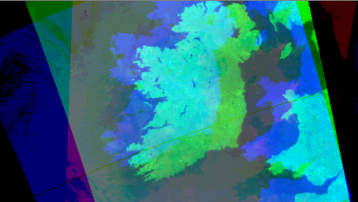
AVHRR NOAA image shows the thermal stratification

Lesson title: Oceanographic Interpretation of Images: Airborne TM data – Southampton Docks
Module No. /Lesson No: M1/L7

Data key: Daedalus 1268 Airborne Scanner
Location: Southampton Docks
Classification key: Harbour, coastal management
Connectivity: M6L4

Aim: To provide experience in the analysis and interpretation of airborne TM data of an estuary.

Location and Data: Southampton Dock is the study area. Six images from 6 channels of Daedalus 1268 Airborne Scanner taken in September 1987 are used for the study.

Procedure: Images may be displayed. Water patterns may be enhanced using stretch. Features and patterns present in each image may be studied. Comparison can be conducted for the spectral signature of different features as well as in different bands. Attempt can be made to distinguish between objects on the water, patterns due to surface roughness, and patterns due to variation of the optical properties of water itself.

Result: In band 6 image, discrimination between land and sea boundaries is clearer. A large vessel, which is moored alongside the dock, is seen in the centre of the image. It has arrived within a few minutes of this image being recorded, and the tugboats, which have helped it to berth, can be observed leaving it. A large plume like feature is visible to the left of the large vessel.

Schematic Representation of the lesson:

Display of the images
Step I

Identification of features

Step II

Comparison of features present in different bands
Step III

Result

Objects like plume, dock, ship and tugboat are observed

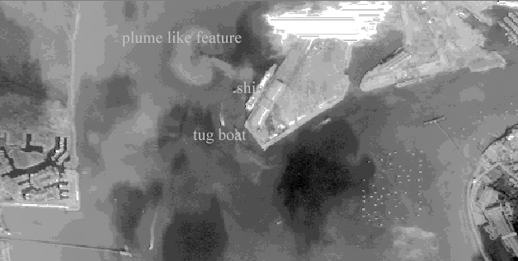
Representative images of the lesson:
Daedalus 1268 airborne image shows different features

Module 2

Lesson title: Analysis of a Synthetic Aperture Radar Image of the Straits of Dover
Module No. /Lesson No: M2/L1

Data key: SAR on Seasat
Location: Dover Strait
Classification key: Waves, coastal management

Connectivity:

Aim: To gain familiarity with digital images of coastal seas as recorded by Synthetic Aperture Radar (SAR), and to learn how best to display the data to reveal ocean features.

Location and Data: The Dover Strait, one of the world’s busiest shipping lanes is the study area. Oceanographically, its significance is that it joins the English Channel to the North Sea, and thus provides the latter with a secondary ventilation to the Atlantic ocean in addition to that between Shetland and Norway.

The image data sets used are all derived from a single overpass of the Dover Straits by the synthetic aperture radar on Seasat, 19th August 1978. Images used in this study have been sampled from the original dataset, with no further change in the pixel values. The processing has produced a geometrically undistorted image having pixels corresponding to a square on the ground of about 24.0 m, centred at 51°16.3′N, 1°57.3′E.

Procedure: Four images is to be analyzed in which image 1, 2 and 4 were of 512X512 pixels and 3rd was of 1024 X 1024. Modified LUT function may be performed to allocate the 16 display colours to the pixel levels. The linear stretch may give the better performance and it reveals the regular, almost Gaussian, distribution of the pixels in the histogram. Palette function can also be tried but monochrome will display the best for interpretation.

Result: In the first image coast of Northern France, the port of Calais, Ostend and Kent coast is visible.
The picture is of grainy appearance due to radar speckle. But smoothing enable some of the true patterns of the image. However that also degrade the resolution of the patterns.

The second image is much smoother because the random noise inherent in the original full resolution image dataset has been greatly reduced by averaging over 49 original pixels, but the resolution is less than the previous one. This image shows the radar-roughness much more clearly.

The texture of the 3rd image is more like that of 1because it is not based on the averaging of pixels and therefore retains the noise caused by speckle in the original data.

The 4th image covers the same area as that of 3 at half the resolution, but with some of the speckles removed by averaging four pixels.

Features like sand bank and deep water are observed in the image

Schematic Representation of the lesson:

Step I

Display of the images

Linear stretching of the images
Step II

Smoothing of the image
Step III

Recognition of sea features like sand bank and deep water
Result

Representative image of the lesson:
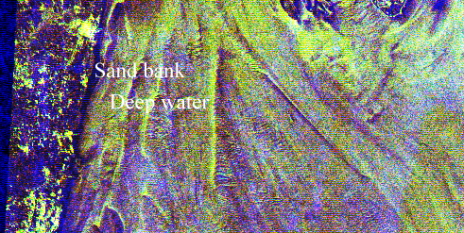
SAR image shows different features

Lesson title: Seasonal Variation of Phytoplankton Distribution in the Arabian Sea
Module No./Lesson No: M2/L2
Data Key: CZCS of Nimbus – 7
Location: Indian Ocean
Classification key: Phytoplankton, coastal management
Connectivity: M5L4 & M5L9

Aim: To use CZCS images to demonstrate the striking seasonal patterns in phytoplankton distribution which occur in the Arabian Sea.

Location and data: Two images of the Indian Ocean region are used. Images are derived from Coastal Zone Colour Scanner (CZCS) of Nimbus – 7 of the months of January 1979 and September 1979. These images are derived products i.e. the satellite data have been processed to estimate a variable that was not directly observed by the satellite.

Procedure: The data is to be log transferred as it is difficult to display such a range of chlorophyll con (from 0.04 to 40 mg m–3) using a linear scale going from 0-255. A comparison between the two images can be conducted. Using the conversion factor the grey scale value can be converted into pigment concentration. Then it is possible to compare the given pigment values and those calculated from the pixel values. Histogram function can be used to study the changes in the pigment concentration between the two images.

Results: The most obvious difference between the two images is that the pixel values on the September image are much higher than on the January image. There is a marked increase in pigment concentration between January and September along the coasts, particularly off Oman and Somali. In September the increased pigment appeared to be drawn out in filaments away from the coast, presumably by offshore currents.

Typically there is a factor of 25 increase between the January and the September pigment concentrations, and this implies a factor of 4 decrease in the penetration depth of solar radiation. Consequently the presence of the phytoplankton can cause the solar energy to be absorbed closer to the surface than would otherwise be the case, leading to increased heating of the surface layer and a reduction of direct solar heating further down in the water column. In this way the phytoplankton community can have an influence on the physical processes which control the ocean's thermal structure.

Schematic Representation of the lesson:

Log transferring the data
Step I

Conversion of the grey scale value into pigment concentration
Step II

Step III

Comparison of the pigment values of two images

Result

There is an increase in pigment concentration between January and September

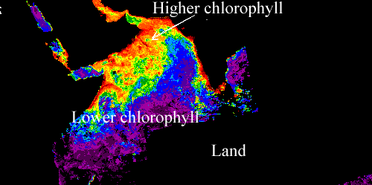
Representative image of the lesson:
CZCS of Nimbus 7 Image shows different chlorophyll concentration

Lesson title: Studies of South American Coastal Discharge Using Landsat Data
Module No./ Lesson No: M2/L3
Data Key: Landsat TM
Location: Brazilian Coast
Classification Key: Suspended load, bathymetry & coastal management
Connectivity: M1L3, M1L5, M3L1, M4L5, M5L5, M5L8, M7L4 & M7L5

Aim: To provide a way of looking at the local bathymetry and monitoring coastal lagoon discharges using Landsat data.

Location and data: Lagoa dos Patos in southern Brazil is the study area, which is the world's largest choked lagoon, with an area of 10,360 km². The lagoon mouth is connected in the south to the South Atlantic Ocean through a 20 km long entrance channel which is between 0.5 and 3 km wide.

5 Landsat TM images of channel 3 were used for the study. Among these two were taken during autumn and two during winter period and last one during rainfall season

Procedure: The images may be displayed with suitable palette. To distinguish between land and sea pixels enhancing can be done with modify LUT option. Comparison of the images may be conducted. It is possible to observe that water flowing seawards forms a hammer head plume type. Shape of the plume may be drawn and length scale may be determined.

Result: Usually, a direct relationship holds between the reflectance at channel 3 and the amount of suspended solids in the water or, in the case of very shallow waters, with the bottom topography.

The shipping channel can easily be distinguished from the top to the centre of the image. It shows up as pixel values in the range of 12-14 compared with the surrounding shallow water which typically has pixel values of 17-20.

From the study, it is revealed that, images showing lower concentration of suspended solids in the water column at times of low water level more clearly show the bathymetric features. In this case, the contrast between bathymetric features and the low reflectance water pixels of image taken during autumn is greater, therefore preferable. The difference in reflectance levels between the images is caused by the different concentration of suspended sediments brought from the drainage basin during the rainfall season.

By observing images of winter period and autumn, it could be concluded that the seaward flow is higher on winter. Because, it was visible, the water flowing seawards forms a "hammer head" plume type.

In the image of rainfall season it is visible wind is blowing from north-east and high reflectance features next to coast area clearly elongated.

Schematic Representation of the lesson:

Step I

Display of images

Enhancing the images using modify LUT

Step II

Applying a colour palette

Step III

A direct relationship observed between the reflectance at channel 3 and the amount of suspended solids in the water

Result

Representative image of the lesson:
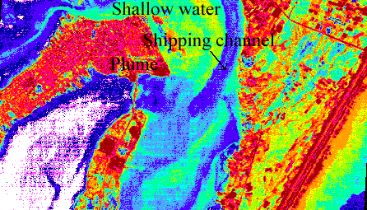
Landsat TM image shows sediment plume

Lesson title: Display and Analysis of Acoustic Doppler Current Profiler (ADCP) Data

Module No./Lesson No: M2/L4
Data Key: ADCP on RD-SC0300
Location: North Pacific Ocean
Classification key: current, open ocean environment
Connectivity:

Aim: To demonstrate the use of BILKO for displaying ADCP data to reveal depth / time velocity variations in the upper ocean.

Location and data: The location is 47°28.9'N, 139°15.4'W, about 1200 km west of Seattle in the North Pacific Ocean. Data is not derived from an imaging sensor on a satellite or aircraft. Data is collected with an RD-SC0300 self-contained 300kHz Acoustic Doppler Current Profiler moored at 110 m below a surface float, looking up towards the surface. The data are arranged in image form with time as the horizontal axis (increasing pixel values along a line correspond to later measurements) and depth on the vertical axis ( increasing line number corresponds to a deeper cell).

Procedure: Images may be displayed with suitable palette. Cursor function can be used to identify eastward and west ward current. By counting the number of flow reversal cycles across the width of the data it is possible to estimate the dominant period evident within the data. Depth variation of the velocity can be conducted by counting down the number of bin from the top. Transect function can be introduced to study the variation of the data with time. The transferring of the storm energy into the interior of the ocean can be observed by looking at the time series of the data at a number of depths. The image can be made more clear by smoothing. The raw data may be displayed to study the gradients of the image.

Result: In the image it is visible 8 flow reversal cells in 127 hours. The dominant period is therefore approximately 16 hours and can be concluded that the oscillation is therefore inertial. From the transects it is able to see the location of the point of zero motion moves left on successive transects, implying that it is moving up in the water column. After overlaying a longer succession of transects, each spaced four pixels, it is possible to see the upward phase propagation. As the time progresses the energy from the storm appears to propagate progressively into the interior of the ocean

Schematic Representation of the lesson:

Display of the image
Step I

Identification of eastward and westward current
Step II

Step III

Estimation of the depth variation of the data with time

Result

Energy from the storm appears to be propagated in to the interior of the ocean with time

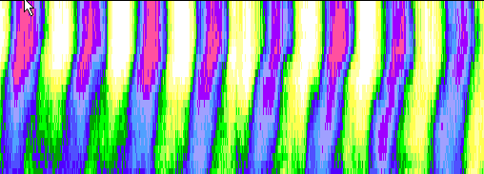
Representative image of the lesson:

ADCP image shows the propagation of energy from the storm to the interior of the ocean

Lesson title: Wind-driven Upwelling off the Coast of South Australia
Module No./ Lesson No: M2/L5
Data key: AVHRR of NOAA –11
Location: South Australian Coast

Classification key: Upwelling, SST & coastal management
Connectivity: M1L4, M1L6, M2L6, M4L1, M4L2, M4L4, M5L3, M5L4, M5L6, M5L7 & M6L1

Aim: To use a sequence of images together with coincident ship-based measurements to look at the evolution of a strong wind-driven coastal upwelling event.

Location and data: South Australian Coast and shelf waters are the study area. Four image data sets are provided for this study. Three are NOAA-11 infra-red images from channels 4 and 5 of the AVHRR sensor, converted to sea-surface temperature using correcting algorithms to account for atmospheric influences. The digital values in these images correspond to °C multiplied by 10, so that the image data range of 0 to 255 corresponds to a temperature range of 25.5°C.

The other image displays data from an Acoustic Doppler Current Profiler (ADCP) mounted on the research vessel (the ORV Franklin). It shows cross-shore and along-shore current velocity components as vertical slices (from approximately 10m below the ship to about 15m above the bottom) measured as the ship crossed the South Australian shelf through the upwelling zone.

Procedure: Images may be displayed with suitable colour palette. For distinguishing the land and sea linear stretching may conducted. Histogram option may be used to determine the mean sea temperature and range of temperature in each image. Transect option may be opted to look at the temperature contrast across the South Australian shelf from the coast to the warmer offshore water. Comparison may be done in order to summarise the way in which the strength of upwelling, as indicated by temperature contrasts and the surface Arial extent. Since Ship Franklin also measured the water properties, a comparison can be made between satellite SST and measured surface Temperature. The temperature gradients associated with the off-shore front between cold and warm waters may be isolated by using the gradients option. ADCP image can be displayed to show the cross-shore component of water velocity and along-shore component. Smoothing can be done to make the velocity structure a little clearer and easier to interpret.

Result: The images show the development of an upwelling event over a seven day period, during which consistent south-easterly winds of 20 to 30 knots were recorded in the region. In image of 1st February, there is no particularly sharp temperature front, rather an increased gradient zone near to the shelf break in which temperatures changed by about 1°C. In image 2, 5 days later, both the overall temperature change from ocean to coast, 5°C, and the change across the offshore front, 4°C, were substantially larger than before. The offshore front was much sharper, lying close to the shelf break. The coldest water was found over the mid-shelf, as opposed to near the coast in the earlier image, and the areal extent of the upwelling is a little larger, mainly due to its extension towards the north-west. In image 3, another 2 days later, temperature contrasts is declined to some extent, with a 2°C - 3°C change across the offshore front, and a 3.5°C overall change from ocean to coast. The offshore front had moved inshore slightly tending to break up in a wavelike manner, and the coldest waters were still found over the mid-shelf.

South-easterly winds are upwelling-favourable winds along this coast and hence the signature of upwelling, seen as a decline in nearshore temperatures, strengthened from image 1 to image 2. The rapid decline of south-easterlies between image 2 and image 3 weakened the dynamical forcing, allowing the density structure to relax back towards its undisturbed state.

The SSTs recorded by the ship matched the measured temperatures very well. The coldest waters, found in mid-shelf, were approximately 12.4°C in the image.

Schematic Representation of the lesson:

Display of the images

Step I

Determination of the mean sea temperature
Step II

Step III

Comparison of the satellite SST and ADCP SST

Step IV

Determination of the temperature gradient associated with the offshore front

Sequential development of the wind driven upwelling
Result

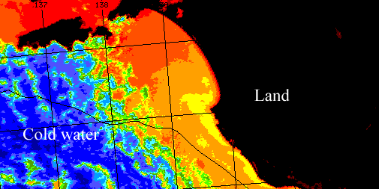
Representative image of the lesson:

AVHRR NOAA-11 shows upwelling region

Lesson title: Surface temperature of the Southern Coral Sea.
Module No./ Lesson No: M2/L6
Data key: NOAA AVHRR
Location: Southern Coral Sea

Classification key: SST, coastal management
Connectivity: M1L4, M1L6, M4L1, M4L2, M4L4, M5L4 & M5L6

Aim: To demonstrate the utility of remotely sensed environmental data from the NOAA 11 satellite-borne AVHRR scanner for mapping thermal structure and monitoring the circulation of tropical oceanic waters on the continental shelf of Northern Australia.

Location and Data: The images cover an area from 143⁰ Longitude in the west to 158⁰ longitude in the east and 14⁰ latitude to the north and 28⁰ latitude to the south. Seven images are provided for analysis comprising near infrared reflectance (NOAA AVHRR channel 2) and sea surface temperature (a combination of NOAA AVHRR channel 4 and 5). The images correspond to four successive days - 17,18,19 and 20 September 1988.

Procedure: Images may be displayed. Histogram option can be used to review the dynamic range for both land and water surfaces in the channel 2 and SST channels. Radiometric masking can be conducted to mask out the coastal land areas from the SST images for 17th, 18th and 19th September. Masked images can be enhanced with modify LUT option until the main thermal patterns are revealed in the oceanic waters. Colour palette also can be applied to produce a colour scale appropriate to the display of water temperature. The number of distinct thermal structures within the scene can be determined by the histogram option.

Result: After enhancing the main thermal patterns is visible in the image. Offshore features become more clear. The emergent reefs are discriminable in the SST images.

Schematic Representation of the lesson:

Display of the images

Step I

Determination of the dynamic range value for both land and water surfaces

Step II

Step III

Radiometric masking of coastal land areas.

Result

Recognition of the main thermal patterns in the oceanic waters

Representative image of the lesson:

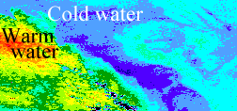
AVHRR NOAA image shows thermal pattern

Module 3

Lesson title: Extent and Content Differentiation of Coastal Plumes
Module No. /Lesson No: M3/L1

Data key: Landsat TM
Location: Johor Province, Malaysia
Classification key: suspended load, coastal management

Connectivity: M1L3, M1L5,M2L3, M4L5 & M5L8

Aim: To introduce the use of multispectral image-enhancement techniques for the identification of river plumes and water quality in coastal regions.

Location and data: The study area concerned a 25 km stretch of coastline in southern Johor Province on the west coast of Malaysia, approximately 50 km north-west of Singapore.
LANDSAT Thematic Mapper band 1, 2, 3 and 6 are taken for the study. The image is obtained at approximately high tide during the inter-monsoon season, when winds and ocean currents are relatively low

Procedure: Images may be displayed. Image contrast can be enhanced with linear stretch to obtain the maximum of 256 grey levels. The extend of three plumes belonging to three streams can be observed. In order to visualise the spectral difference between pixel values for the different water types transect option can be used. Two band ratioing can be applied to exhibit the inherent differences in radiance characteristics between two wave bands. To obtain a better visual effect, paletting, smoothing and manual stretching can be applied. This procedure may be effectively classifying the image by density slicing, producing a map of water quality.

Result: It is visible that the plume 2 is small, very dark which hugs the coast in the centre of the image. In the band 1 tonal difference between plumes 1, 2 and 3 and also between the plumes and non-plume water was noticed. It was noticed that plumes 1 and 2 are just separable from plume 3 but that plume 3 values overlapped with those of non-plume water. In band 3, the mean, and range of values for both plume types are similar (not spectrally separable), but values for non-plume water are considerably lower, thus separable.

Plumes 1 and 2 exhibited consistently low reflectance in the short wavelength region, with moderate values in band 3, characteristic of yellow substance-dominated water. Plume 3 has higher reflectance in band 1, similar to the values for non-plume water. In band 3 its reflectance values are lower and closer to those of Plumes 1 and 2. Thus Plume 3 resembled water containing suspended sediment. Since it is highly probable that all the imaged plumes contain significant quantities of both suspended sediment and yellow substance, and the coastal non-plume water is highly turbid, the band 3 is far from exhibiting the zero reflectance expected of clear blue water.

Schematic Representation of the lesson:

Step I

Display of the images

Step II

Identification of the three plumes

Step III

Application of two band ratioing

All the imaged plumes contain significant quantities of suspended sediment and yellow substance
Result

Representative image of the lesson:
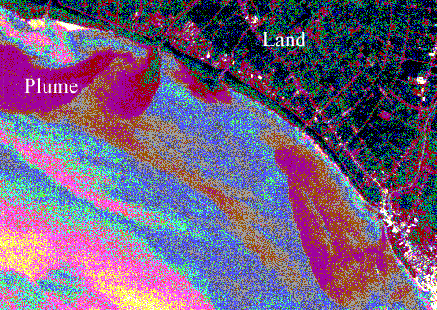
Landsat TM image shows plumes

Lesson title: Using Landsat for Coastal Management-1: Mapping and Determining Major Substrate Categories.
Module No. /Lesson No: M3/L2

Data key: Landsat TM
Location: Desert coastline along Red Sea
Classification key: Habitat, coastal management
Connectivity: M6L2, M7L1, M7L2, & M7L6

Aim : To illustrate how to map a remotely and rarely visited, inaccessible coastline. The mapping includes estimating, accurately and quantitatively, the locations of important features such as coral reefs, the exact shoreline and major terrain and habitat types. Preliminary bathometric information is also obtained.

Location and data: The scene provided is of a desert coastline along the Red sea. It is an image from the Thematic Mapper (TM) of Landsat. The region concerned is rarely visited and is inaccessible. Bands 1 to 4 of the Landsat TM image of the study area are utilised. The size of the image portions was 15.36 × 7.68 km on the ground.

Procedure: Images may be displayed. For distinguishing the land from the sea radiometric masking of the images can be done. For this two bands may be used and sea and land area can be successively masked. Land sea boundary will be visible. Masked images can be saved separately. A gradient filter also can be applied to identify land-sea boundary. Smooth filtering can be applied on the sea images and texture filtering on the land image. Palate option may be used to give different colour with respect to reflectance. After paletting, presence of habitats can be checked.

Result: The original image does not show the coastline at all clearly because the blue green light, which the wave bands responds reflects nearly as strongly from the sea bed through shallow water as it does from the surrounding dry land. The masked image exactly shows the coastline. It is seen that in the larger wavelength, reflectance from pixels defined as sea becomes less because, the water tends to absorb the larger wavelength of light. Sea image (land masked image) showed to be best for delineating the land-sea boundary. Gradient filtering gives a thicker and more diffuse line may not give the sharpest boundary. After paletting presence coral reefs observed.

Schematic Representation of the lesson:

Display of the image
Step I

Masking of land and sea

Step II

Application of filter
Step III

Identification of land-sea boundary
Result

Representative image of the lesson:
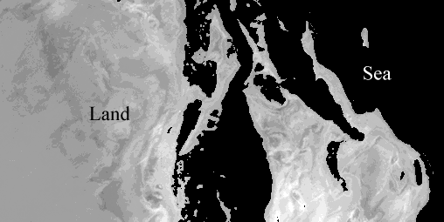

Landsat TM image shows land sea boundary

Lesson title: Using Landsat For Coastal Management – 2 Vegetation Mapping
Module No. /Lesson No: M3/L3

Data key: Landsat TM
Location: Desert coastline along Red Sea
Classification key: Vegetation, coastal management
Connectivity: M3L3, M4L1, M5L1, M5L2, M6L3, M7L1, M7L2, M7L7 & M7L8

Aim: To develop simple classification procedures to illustrate how vegetation can be identified from a Landsat TM image, how the area of important vegetation stands in the image can be quantified.

Location and data: The study area is a desert coastline along the Red sea. It is an image from the Thematic Mapper (TM) of Landsat. The region concerned is rarely visited and is inaccessible. Bands 1 to 4 of the Landsat TM image of the study area are utilised. The size of the image portions is 15.36 × 7.68 km on the ground.

Procedure: Images may be displayed. Appropriate palette can be applied. An investigation can be conducted to distinguish vegetation habitats. A combination of the red and infra-red can be utilised to pick put the information vegetation information. Minimum value in the red and infra-red band may be determined. Subtraction of these value from every pixel in the red and infra-red can be made separately. Image ratioing of the of infra-red over red can be performed. This will show the vegetation and suitable stretching can be done in order to see the habitats clearly.

Result: Four habitats viz. Mangrove 1, mangrove 2, algal mats and Sargassum in large strip on reef edge. In the band 3, the values of pixels are lower at mangrove 1than the surrounding area. However in the channel 4, the corresponding mangrove 1 pixels were both higher and lower than the surrounding, which conclude that this wave band alone can not be helpful for the vegetation cover. By subtracting the dark values from each image, the range of the numbers in the image increased and thus improved potential for discrimination between different ratios. The usefulness of the ratio image lies in the way it shows up patterns of high and low values. There was a broad spread of pixels which have high to very high ratios. With that four colour displayed the red pixels represents the locations containing the most chlorophyll, and yellow pixels those probably containing some chlorophyll.

Schematic Representation of the lesson:

Step I

Display of the image

Step II

Finding out minimum pixel value in the red and infra-red bands

Step III

Subtraction of the values from every pixel in the respective band

Step IV

Two band ratioing

Identification of the vegetation habitats like mangroves, agal mats and Sargassum

Result

Representative image of the lesson:

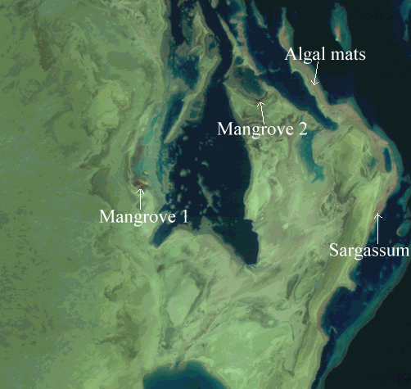
Landsat TM image shows different vegetation habitats

Lesson title: Detection of Potential Areas for Coastal Aquaculture Using the Indian Remote Sensing Satellite – IRS 1A
Module No. /Lesson No: M3/L4
Data key: IRS-1 A LISS 1 & 2, Landsat MSS
Location: West Coast of India
Classification key: Aquaculture, coastal management
Connectivity:

Aim: To introduce a method of data interpretation for a newly emerging area in coastal research using the Indian remote sensing satellite.

Location and data: The study area is a major estuarine system, the Aghanashini estuary on the west coast of India. The area extends from 14°28′ to 14°32′N and 74°21′ to 74°32′E.

LISS 1 & 2 images of IRS 1A on 14th January 1990 was selected for comparison with the synchronous ground sampling. To identify temporal changes, data from 1989 and 1984 were also obtained. The 1984 data were taken from Landsat MSS as LISS was not available then. Both the sensors worked in 1,2,3and4 wave bands.

Procedure: Images may be displayed. Histogram option can be used to find out the maximum and minimum values of grey levels. Linear stretching can be applied to stretch image between the minimum and maximum grey levels. Transect option can be utilised to plot the transect of different area and this an be used to relate the various features of the transect to the ecology of the area. It may be possible to observe that image show many classes and it may be regrouped into small number of classes. For the regrouping manual stretching can be used. Paletting can be performed for getting contrasting colours. Estimation of the number of pixels in each classes may be done and from this area of each classes can be obtained. Using this classification, change in the area of classes between 1984, 89 and 90 can be found out and can be found out which part of the estuary appear to have undergone substantial change. Weighted index image of 84, 89 and 90 may be displayed with stretching and paletting. Using histogram option number of pixel in each weight can be found out and from this area of each weight in km² can be estimated. Area defines suitable for aquaculture may be identified from the weight. Evaluation of the temporal changes in total aquaculture area in the estuary may be performed. A comparison of the two methods for estimating aquaculture area can be conducted.

Result: There are evidently difference in the patterns of pixel values between the different bands and this can help in distinguishing between water types. As per the maximum likelihood classification the area of estuary channel, mangrove and tidal flats showed an increase in area from 89 to 90 but a decrease showed in aquaculture area. Distribution of area for aquaculture as per the WIS showed a decreasing trend in wt. 0, 2, 4, 5 and 6 but an increasing trend in wt. 1, 3 and 7 and a total increase in area of around 2 km²

Schematic Representation of the lesson:

Display of the image
Step I

Classification as per maximum likelihood

Step II

Classification as per Weighted Index Scheme
Step III

Result

An increase in aquaculture area as per WIS

Representative image of the lesson:

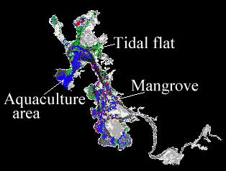
LISS image shows aquaculture, mangrove and tidal flat area

Lesson title: Study of Coastal Lagoonal Features Using IRS-1A LISS Data
Module No. /Lesson No: M3/L5
Data key: LISS 1&2 IRS-1A, Landsat MSS
Location: East Coast of India
Classification key: Vegetation, coastal management
Connectivity M3L4, M4L1, M5L1,M5L2, M6L3, M7L1, M7L2, M7L4 & M7L8

Aim: This lesson introduces the dynamical features of a tropical coastal lagoon and the fundamental ways of studying them using remote sensing techniques. It provides a case study using an Indian coastal lagoon.

Location and Data: Chilka lagoon (19°28′ to 19°54′ N and 85°35′ to 85°67′ E), of the east coast of India, is the study area. The lagoon is connected to the Bay of Bengal by an outer channel of approximately 25 km which is separated from the sea by a long narrow sand spit.

The image data are from the LISS sensor on the Indian Remote Sensing Satellite (IRS-1A), and also from the MSS on Landsat.

Procedure: Images may be displayed with stretching and palette. Different ecological features can be identified. Scatterograph function can be used to examine the relative values in pairs in channels. NDVI function can be used to determine vegetation index from red and IR band of LISS and Landsat data. Images may be saved and features may be identified. Comparison can be conducted for the two resultant images and interpretation may be possible in terms of changes to the lagoon over the 4 year period. Classified images of the 2 years provided may be displayed with linear stretch. The 14 classes can be combined to approximate to 5 classes with manual stretch. Different colours can be given so that 5 colours will represent 5 classes. Number of pixel in each classes can be calculated and from this area of each features in sq. km can be obtained. By comparing the two classified images it may be possible to identify the temporal changes in the ocean.

Result: Ecological features like submerged vegetation, gelbstoff, inorganic suspended load, emergent vegetation and wed free zone are identified. Emergent vegetation highlighted by applying NDVI of red and IR . After the comparison of the MSS images of 1984 and Landsat images of 1989, it is found that over a period of 4 years, the sedimentation of weed zones have increased progressively in area, choking the lagoon. Consequently the weed free zone has decreased in area around 20 km². It is clear that lagoon is transforming very rapidly the ecological features which are inherent are dynamically active.

Schematic Representation of the lesson:

Display of images of LISS and MSS Landsat
Step I

Derivation of vegetation index with NDVI

Step II

Reclassification of the classified image
Step III

Estimation of area of each features
Step IV

An increase of emergent and submerged vegetation over time
Result

Representative image of the lesson:
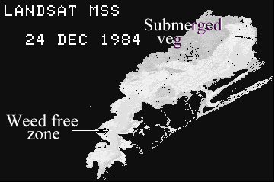
Landsat MSS shows Submerged vegetation and weed free zone

Lesson title: Temporal and spatial variations in sea ice concentration in the southern ocean
Module No. /Lesson No: M3/L6
Data key: SSM/I
Location: Southern Ocean
Classification key: Sea ice, open ocean environment
Connectivity:

Aim: To use a sequence of images to look at the seasonal cycle of sea ice extent and sea ice concentration on the southern hemisphere.

Location and Data: The study is conducted at southern ocean with sea ice concentration images. 12 SSM/I (Special sensor microwave imagery) sea ice concentration images of the Southern hemisphere are used to determine the high seasonal variability of the ice coverage around Antarctica. The data are daily averages of the first completely mapped day of each month in 1989. SSM/I is a seven channel passive microwave radiometer system.

Procedure: SSM images may be displayed with palette. It may be found that all values except those from land areas are represented by colours from the lower part of the palette. Land can be masked with histogram. Land mask can be separately coloured to distinguish more clearly between ocean and land. Selection of the two images can be made showing minimum and maximum ice coverage. Subtraction of the two images may be done to get an impression of the seasonal variability in ice coverage. Image showing relatively large ice extent may be displayed and gradient option can be used to calculate the regions of high spatial variability in ice concentration.
Brighter temperature images may be displayed. Scatterograph can be prepared with these two images and is possible to identify the region for the open water tie point and for the line describing the 100 % ice concentration. After applying VGA palette it can be noticed that variations in concentration is relatively high even in regions with very high absolute values of ice cover.
AVHRR image may be displayed. Large variation in reflectance may be noticed. Single ice floes can be clearly distinguished as bright from a very small leads of open water or thin young ice a dark. Smoothing can be conducted several times and decrease in spatial variation can be observed.

Result: From the images it is observed that maximum ice extents happened in September and minimum in February. Maximum gradient in the ice concentration is found at marginal ice zones and at the continental coast where an offshore wind temporarily creates open water areas. Variability in ice concentration is related to the high variability of the wind forcing which causes the opening and closing of open water leads in the ice coverage.

Schematic Representation of the lesson:

Display of the images
Step I

Masking of land for getting land-sea boundary
Step II

Step III

Observation of seasonal variability in ice coverage

Step IV

Calculation of the region of high spatial variability

Maximum ice extent observed in September and minimum in February
Result

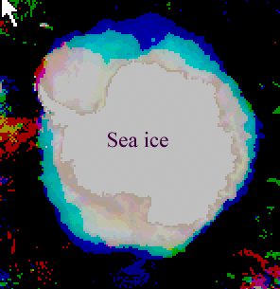
Representative Image of the lesson:

SSM/I image shows sea-ice concentration

Lesson title: Global Waves and Winds from Geosat
Module No. /Lesson No: M3/L7

Data key: Radar altimeter
Location: Global ocean
Classification key: Waves, open ocean environment

Connectivity:

Aim: To show how global data sets of satellites derived wave height and wind speed over the ocean can be examined in image form and related to each other.

Location and Data: Images used for this study consists of global datasets of monthly means of Significant Wave Height and Surface Wind Speed. These have been obtained from radar altimeter on the Geostat satellite for the month of July and January between 1986 and 1988.

Procedure: Images of wave height may be displayed with suitable stretching and palette. Values of the maximum wave height and strength and the pattern in the image can be estimated. A comparison of the high of waves with respect latitude can be done.

Wind image data can be displayed with stretching and paletting. Here also maximum wind speed and its position can be found out. Comparison of the image data of different month can be calculated. Comparison can also be done for the wind and wave data. A quantitative comparison of the wind and wave distribution can be made using scatterograph function.

To identify regions where the waves are lower than might be expected from the general relationship with wind, two band ratioing can be performed. Inter annual variability can be examined to calculate the difference between monthly mean for a particular year and the mean over years of the data for that particular month. Image arithmetic option can be used for this. An annual mean can be constructed from the January and July 1987 and 1988.

Result: In January 1987, a band of high waves occurred across the mid latitudes of the Northern hemisphere with highest in the North Pacific, maximum wave height being about 5.9m and in July 1987 high wave high wave height occurred at the mid latitudes in Southern Ocean. Comparison between winter and summer shows that in the northern summer the waves are very low whereas southern summer waves are high. Wave height distribution of the 3 July images shows similarity and the two January images also seem very like each other.

In the January 1987, strongest wind are found in North Pacific and Atlantic ocean but in July data shows a high belt of high winds only in southern ocean.

The wind and wave pattern for July correlate well with each other as do the wind and wave images for January. It is evident that wind distribution tends to control the wave height distribution.

Schematic Representation of the lesson:

Display of the wind and wave images
Step I

Observation of spatial and temporal nature of wind and wave
Step II

Step III

Calculation of inter annual variability

Step IV

Calculation of annual mean

Wind distribution tends to control the wave height distribution

Result

Representative image of the lesson:
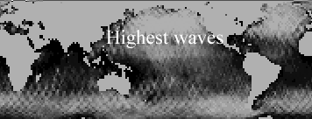
Geosat image shows global waves during January 1987
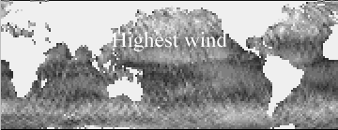
Geosat image shows wind speed during January 1987

Lesson title: Ocean Eddy Dynamics Generated by a Numerical Model
Module No. /Lesson No: M3/L8
Data key: Computer based ocean model
Location:
Classification key: Current, simulation
Connectivity:

Aim: To demonstrate a numerical model of deep ocean eddies using BILKO for display and analysis

Location and data:

Procedure: Images of the streamfunction of the different layers may be displayed with VGA palette. It can be identified the number of eddies and its nature. Transect function may be used to display the streamfunction for different section. The exact coordinates and values of streamfunctions may be noted. Horizontal component velocity in the ocean eddies can be obtained be using finite difference equation. Relative vorticity images may be displayed. Cursor function can be used to obtain true values of the vorticity field. Comparison can be made between streamfunction field and vorticity field. It may be possible to identify the position and values of the maxima and minima in streamfunction and corresponding vorticity field. This evolution of the eddy field can be obtained by comparing either the streamfunction or vorticity image at the same level but at two different times.

Result: The flow around the eddy centered at x=62 and y=57 of the surface circulates in a counter clockwise direction (cyclonic in Northern Hemisphere) and for the eddy centered at x=83 and y=92 has a clockwise circulation (anticyclonic in the N. hemisphere). The vorticity estimated from the stream function field centered at x=62 and y=57 is +8.06 x 10^{–6} S⁻¹. The westward displacement of the eddy in the lowest layers is seemed to be consistent with the change of the horizontal baroclinic pressure gradient with depth. The decay of the streamfunction with depth is related to the superposition of the barotrophic and baroclinic pressure gradients. In the upper layers of the model the two components of the pressure gradient tend to reinforce one another, while in the lowest layers they tend to cancel each other. In the ocean, the external pressure gradient caused by slope of sea level tends to be compensated by the internal pressure gradient caused by density variations. It is seen that thermocline tends to oppose the sea surface pressure gradient, thus geostrophic flow tends to be stronger in the upper layer.

Schematic Representation of the lesson:

Display of images of streamfunction and vorticity of different depth
Step I

Identification of number and nature of eddies
Step II

Step III

Estimation & comparison of value of streamfunction and vorticity

Step IV

Identification of fine evolution of eddy filed

The decay of streamfunction is observed with depth
Result

Representative image of the lesson:
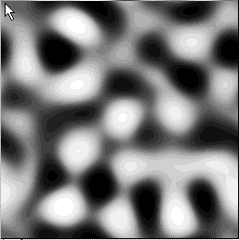
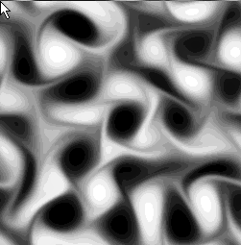
Image of streamfunction Image of vorticity

Module 4

Lesson title: Image in-situ bio-optical and physical parameters
Module No. /Lesson No: M4/L1

Data key: Biowatt II, MVMS
Location: Sargasso Sea
Classification key: SST, vegetation & coastal management

Connectivity: M1L4, M1L6, M2L6, M4L2, M4L4, M5L4, M5L6 & M6L1

Aim: To use colour imaging to represent time series from automated sensors moored at several different depths.

Location and Data: The study area is the Sargasso Sea located north of the subtropical convergence zone within and to the west of the north Atlantic gyre. The data is collected by multi-variable moored system (MVMS) during Biowatt II. Experiment from March to November 1987.

Procedure: Chlorophyll image may be displayed. High and low chlorophyll values may be observed using suitable colour and stretch options. The maximum chlorophyll depth can be determined using cursor and transect options and time series graph may also be displayed. Temperature image may be displayed. Palette and stretch can be applied and the number of thickness of the isothrms change over time may be noted. Using transect option depth may be determined and graph may be plotted. Current velocity image may be displayed and palette and stretch may be applied. Depth (10 m) may be determined and time series velocity graph may be plotted to illustrate mesoscale processes associated with a cyclonic eddy from day 1-15. To determine if the higher frequency have an inertial periodicity, the result of Coriolis effect, a graph of 11 day time series may be plotted. Base of the mixed layer can be determined by re-plotting velocities for other depths in 20 pixel increments using the 10 m time series as the reference. All the three images may be compared.

Result: The high chlorophyll values are seen in green and low in red-black colour. The depth of the chlorophyll maximum (DCM) peak is approximately 80 m and it extends from 60-105 m. The chlorophyll profile is not constant for time scale of less than approximately three days. Chlorophyll has 10-11 cycles or a periodicity of approximately 1/day, which coincides with daily light periodicity. The cycle on the sixth day, which does rising chlorophyll values associated with a cyclonic eddy that is, advected past the mooring obscure. The variability on shorter time scales results from waves (e.g. Tides and internal) as well as physiological processes associated with pigments. In the temperature image colder water is seen in blue and has an integer value of 150, the warmer water in red colour with integer value of 50. The temperature change is 1 C / 5 integers. The largest gradient is between 45-60 m and is the seasonal thermocline. The peak DCM value is approximately 80 m, so it is 20 m below the bottom of the seasonal thermocline: it is associated with relatively high nitrate concentrations. The chlorophyll in the DCM may represent new production; that is, production based on vertical nitrate dispersion through the thermocline. The DCM transverses three or four isotherms and does not seem to follow the general trend of in situ temperature. The DCM may be the result of other advective processes, as well as differential growth of cell and sinking of phytoplankton, marine snow, and detritus. In current velocity image, mesoscale activity is evident in the isotherm time series and is visualized as shallowing then deepening isotherms during the passage of a cyclonic eddy. This is most likely a result of the edge of the eddy, composed of warm Gulf Stream water, passing over the mooring. The DCM also responded to mesoscale forcing as is evident by the coincidence of the highest chlorophyll values during the passage of the eddy. The cyclonic eddies are upwelling structures that often have high chlorophyll values associated with changing vorticity of the flow field. The current in isotherm both has inertial period.

Schematic Representation of the lesson:

Display of the images
Step I

Plotting time series graph using 10 m depth as a reference
Step II

Comparison of the images
Step III

Chlorophyll, temperature and current velocity profiles obtained
Result

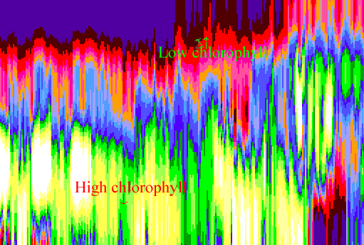
Representative image of the lesson:

Biowatt II MVMS image shows the high and low chlorophyll areas

Lesson title: Spatial-Temporal Evolution of the Coastal Upwelling in the Senegalese and Muritanian Littoral
Module No. /Lesson No: M4/L2

Data key: IR images of Meteosat
Location: West African coastline
Classification key: SST, upwelling, coastal management

Connectivity: M1L4, M1L6, M2L5, M2L6, M4L1, M4L2, M4L4, M5L3, M5L4, M5L6, M5L7 & M6L1

Aim: To show the dynamics of the sea surface temperatures in a area of coastal upwelling along the Senegalese Coast of West Africa using Meteosat 4 infra red images.

Location and Data: Study area is a 1500 km stretch of the West African Coast line, from northern Mauritania (21 N) to southern Guinea (9 N). Geostationary Meteosat 4 IR images were used to study SST in an area of coastal upwelling along the Senegalese coast of West Africa.

Procedure: Image may be displayed. Thermal structures over the sea can be distinguished using suitable stretching. Palette may be applied and using cursor, minimum and maximum temperatures along the three transects running from west to east may be determined. Monthly mean image of SST from December 1991 to June 1992 may be displayed to determine the extent of the upwelling during this season and change between successive months may be investigated.

Result: The image shows the beginning of the coastal upwelling along the coast of Senegal and Mauritania. North of Dakar, the coldest waters are close to the coast, because the continental shelf is narrow. The maximum upwelling of water occurs above the 200-m isobath, that is, near the boundary of the continental slope. South of Dakar, the coldest water is progressively more distant from the coast because of the wider extent of the continental shelf. The filament of cold water far offshore from the continental shelf to the west is noticed.

Lowest temperature is shown in light blue and the highest in red colour in the image. The minimum temperatures along three transect running from west to east be determined: Just south of Dakar, offshore from the Soloum estuary and offshore from the Casamance river.

The mean of the three minimum temperatures is approximately 19.5 C. The southern limit of the thermal front is located south of the Bissagoh archipelago (Guinea Bissau). The comparison of these 7 images shows a considerable reduction in the surface temperature of the coastal water from December to March, an increase of the temperature could be seen from March to June.

During the 1991 to 92 cold season, the shift observed in the maximum intensity of the upwelling corresponded to a delay in the trade winds, which are maximum in April in the Dakar area, instead of the usual February to March.

Schematic Representation of the lesson:

Display of the images
Step I

Determination of minimum and maximum temperatures along three transects
Step II

Determination of extent of upwelling during the season
Step III

The trade winds along the coast generate the upwelling of cold waters

Thermal structure and extend of upwelling over the sea is observed

Result

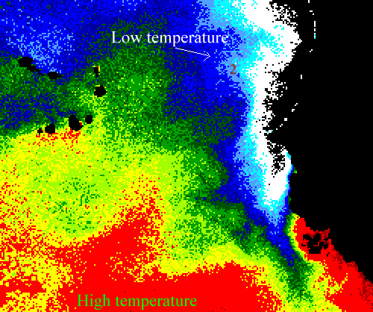
Representative image of the lesson:

IR image of Meteosat showing SST

Lesson title: Variation of a AVHRR-Derived Sea Surface Temperature with Satellite Zenith Angles
Module No. /Lesson No: M4/L3

Data key: AVHRR of NOAA 9 & 12
Location: West Indian Ocean
Classification key: Correction of error induced by satellite zenith angle, simulation

Connectivity:

Aim: To understand the scale and sense of the error induced by the satellite zenith angle on the calculation of sea surface temperature and the need to correct for it.

Location and Data: Study area is the West Indian Ocean. Sensors on the NOAA 9 & 12 satellite are used to make a comparison of two satellite images in order to assess the error induced by the zenith angle. The image of June 1992 is covering an area between Latitude 11.2-15.9 S and Longitude 45-49.25 E and the image of September 1992 is representing an area between Latitude 20.8-25.3 S and 40.5-44.76 E Longitude.

Procedure: Image of June 1992 may be displayed. To facilitate the visualisation contrast stretch and palette may be applied. Using cursor correspondence between temperature and view angle may be established. The information about the location of view angle of the temperature pixel may be found out. An area having the same view angle for the two satellites may be determined. Brightness temperature of few selected pixels may be compared and their mean difference can be estimated. Image of September 1992 may also be displayed and temperature error caused by view angle error may be noticed. Images showing the difference in temperature in the zenith angle of the two passes may be displayed. The results of temperature error and view angle of these images may be compared with the previously displayed images.

Result: The upper right of the images has about the same view angle for the two satellite passes. The brightness temperature difference is less than 0.4 C; the mean of difference is only about 0.1- 0.2 C. This means that the calibration between the two sensors is good. It is noticed that as a consequence of the temperature error caused by view angle error, some clear pixels are treated as cloud pixels by temperature test. It is noticed that the angle difference is only 30 degree in the lower part of the image (less than the upper) and the temperature difference is higher (above 1 degree). The error induced by the satellite zenith angle is not linear.

Schematic Representation of the lesson:

Step I

Display of images

Establishment of correspondence between view angle and temperature
Step II

Step III

Location of pixel view angle information

Comparison of the absolute difference of temperatures and view angles for the two passes of the images
Step IV

Calibration between the two sensors observed less error
Result

Representative image of the Lesson:
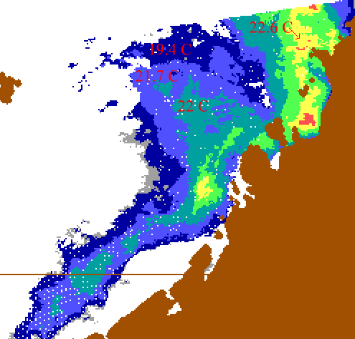
AVHRR NOAA image shows SST

Lesson title: Seasonal and yearly variation of surface temperature distributions in the North Sea.
Module No. /Lesson No: M4/L4

Data key: AVHRR NOAA
Location: The North Sea
Classification key: SST, coastal management

Connectivity: M1L4, M1L6, M2L6, M4L1, M4L2, M5L4, M5L6 & M6L1

Aim: To understand the thermal structure of the North Sea by showing seasonal course and the annual variability of the sea surface temperatures (SSTs), as measured by NOAA satellites.

Location and data: North Sea is the study area. SST images of AVHRR NOAA are used for the present study.

Procedure: A sequence of SST monthly composites between January 1990 and December 1991 may be displayed. Changes of the SST during the year may be determined and the effects of sea convective and advective processes on SST may be considered. SST composed of February, August 1990 and February, August 1991 may be displayed. Main currents in the image may be observed. Images may be compared for SST.

Result: The SST is changed by convective and advective processes. The advective processes concern the transportation of water by currents and tides. The convective processes concern the air-sea interaction, solar heating and vertical mixing of the water column. The water depth has a large influence on the mechanism of cooling and warming of the North Sea water as a result of air-sea interaction and solar heating. Three currents in the SST imagery are visible. These currents are current through the English Channel, the current around the north and Scotland along the British East Coast and the Norwegian coastal current. The first current was an affluent of Atlantic Ocean. The temperature contrast between Atlantic and North Sea is at a maximum during the winter months. The second current is relatively cold at all seasons. In the winter, the temperature of the ocean water is a little warmer than that of the North Sea, and in summer, the penetrating ocean water is much colder than that of the North Sea. The Norwegian coastal current is colder in winter and in summer warmer than the North Sea. This is clearly visible in the images of June and August.

Shallower and deeper areas in the images are distinguished. In April (Summer) image, it is seen that shallow water along the coast is warmer and in the October (winter) image the shallow water are cooler than the deep water.

The cold current of ocean water along the British East Coast was clearly visible and the Norwegian coastal current is partly visible in the images. In 1990 the shallow waters along the coasts in the southern part of the North Sea are a few degrees warmer than in 1991 but the cold deep waters in the north west part extend further to the south in 1990. The lower wind speeds in 1990 do not explain this difference in the SST pattern. This may be due to the difference in the distribution of solar heating over the North Sea in two years.

In the February 1990 image, the current through the English Channel is easily recognizable. The Norwegian coastal current is just discernable. The SSTs in the February 1990 are much higher than in 1991. The air temperatures in 1990 are very high with regard to the climatology. The extremely high winds contributed to a rapid transfer of the atmospheric heat to the North Sea water. The largest SST difference between 1990 and 1991 are found in the shallow waters in which temperatures are more sensitive to atmospheric variations.

Schematic Representation of the lesson:

Display of images
Step I

Step II
Observation of SST distribution changes during the season

Step III

Identification of main currents

Step IV

Comparison of SST distribution between two bathymetry of the sea

Result

The deeper waters are less sensitivity to extra atmospheric variations than the shallow waters.

Representative image of the lesson:

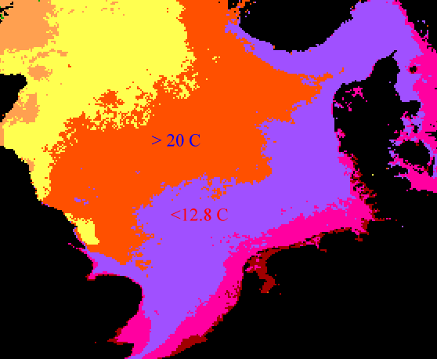
AVHRR NOAA image shows SST

Lesson title: Analysis of the Turbid Plume of the Gironde Estuary (France) Using SPOT Data
Module No. /Lesson No: M4/L5
Data key: SPOT XS
Location: Gironde estuary (France)
Classification key: Suspended load, coastal management

Connectivity: M1L3, M1L5, M3L1, M2L3 & M5L8

Aim: To understand how to monitor estuarine discharge in lesson using SPOT data

Location and Data: The study area is the Gironde estuary, France. Five SPOT XS images are used for the study. In this first four are in 1986 and the last in1991.

Procedure: Images of the channel 1 to 3 of year 1986 may be displayed. Different fronts and seaward extension of the turbid plume may be seen applying stretch to the image. Comparison of the three channels may be conducted. To study the turbid plume channel 1 and 2 may be added using image arithmetic option. Several turbid fronts may be viewed in the resultant image after paletting and stretching. Turbid profiles across the plume may be displayed using transect function. Images of channel 1 of year 1986 and 1991 can be compared.

Result: In the channel 1 image of 1986, turbid waters are visible as patches limited by fronts around the mouth of the Gironde. The extension of the turbid plume is approximately 45 km East-West and North-South. In the channel 2 image, the maximum extension of the turbid waters westward is no longer visible. In the channel 3 images the turbid plume is no longer visible.

The XS1 channel is proved to be best adapted to give the maximum amount of information on those waters where the concentrations of solid matters are low. On the other hand, the XS 2 channel provides more precise information than the XS1 channel for water in which the turbidity is high. The XS3 channel is extremely useful for finding the precise limit between water and land, as the wavelengths of this channel are massively absorbed by the water which then shows up dark.

Several turbid fronts are visible in the added image. It is visible on the east west profile, the concentration in suspended sediment material progressively increase towards the estuary. A front limit is clearly marked in the west between the clearer and turbid waters.

These various fronts indicated several phases of discharge of suspended material over the 48 hrs preceding April 30, 196. At each ebb tide, silts and clays are driven seawards in the form of a turbid plume.

The north south profile cuts through part of the turbid plume perpendicularly. The concentration decreased progressively and regularly towards the south. There is a sharp front in the north indicating a very distinct limit between the turbid waters of the turbid plume and the clear water of the continental shelf.

In the image of 91, the turbid plume has not left the estuary and the turbidities on the continental shelf are low. This image is thus totally different from that of 86 where the outer turbid front is 45 km off the mouth of the estuary. What is even more indicative is that the fluvial flow rates are very different. The 91 image corresponds to a period of average flow rates (900 m³s⁻²) and there had been no high flood in the in the pervious months. On the other hand, image of 86 corresponds to a period of relatively high fluvial flood (> 2000 m³s⁻²) and the estuarine waters are extremely turbid.

Schematic Representation of the lesson:

Display of the images
Step I

Comparison of the images
Step II

Study of the turbid plume and turbidity fronts
Step III

Turbidity fronts are seen and the extent of the turbid plume is 45 km EW and NW
Result

Representative image of the lesson:
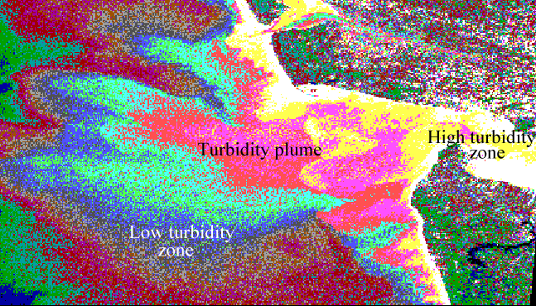

SPOT XS image shows the turbidity plumes

Lesson title: Detection of Sea Surface Life With an Airborne Synthetic Aperture Radar
Module No. /Lesson No: M4/L6
Data key: SAR images
Location: Mediterranean Coast
Classification key: Sea life, open ocean environment

Connectivity:

Aim: To gain familiarity with digital images of fishing events as recorded by an airborne Synthetic Aperture Radar (SAR).

Location and Data: Golfe du Lion off the western Mediterranean coast of Europe (South of France) is the study area. 3 SAR images are used for the present study.

Procedure: Images may be displayed. Stretching may be applied. Identification of the features may be done. Length of the features may be estimated. The pixel values representing different features may be compared.

Image representing Tuna school may be displayed to visualise the Tuna school. Using histogram the distribution of the pixel corresponding to the Tuna school may be examined. The other two image representing purse seiner and two whales may be displayed. Length of the whales can be estimated using cursor function. Values of pixels representing whales may be compared with the pixel values of Tuna school. Contour of whales may be seen using filter function.

Result: Tuna school is visible as a bright patch in the upper left of the first image. Higher values of Tuna school are caused by the presence of fishes in the school. A radiant gradient of the backscatter is observed, which is due to the higher density of jumping fishes in the middle of the school.

A purse seiner with its net is observed in the second image. The net looks like a circle. Inside the net Tuna school and speed boat are observed. The Tuna boat is clear spot in the lower left part of the image. A swell is also visible in the image.

Two whales are seen swimming side by side in the third image. Some pixels showing the whales showed the saturation of the signal. This is probably caused by the reflection on the skin of the whales.

Schematic Representation of the lesson:

Display of the images
Step I

Stretching of the images
Step II

Identification of the features
Step III

Tuna school, purse seiner and two whales observed in the images
Result

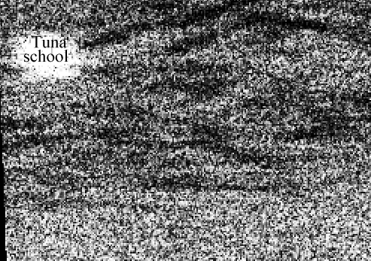
Representative image of the lesson:
SAR image shows the Tuna school

Lesson title: Bathymetry Prediction From Satellite Altimeter Data
Module No. /Lesson No: M4/L7

Data key: Bathymetric data of DBDB5, Geosat GM
Location: Pacific Antarctic Ridge
Classification key: Bathymetry, open ocean environment

Connectivity:

Aim: To predict bathymetry from gridded radar altimeter measured by earth-orbiting space craft over remote ocean where conventional ship borne depth surroundings are sparse but satellite altimetric measurements are dense and evenly spaced.

Location and Data: Pacific Antarctic Ridge is the study area. Three basic image data sets are provided. They are (a) archival bathymetry data derived from DBDB5, a global digitally gridded bathymetry database of ship based observation, (b) High pass filtered Geosat GM data and (c) bathymetry predicted from the satellite derived geoid.

Procedure: Archival bathymetry image may be displayed. Regional variability of the bathymetry can be seen using suitable stretch. Few profiles across the mid ocean ridge may be observed using transect and image arithmetic option. Geosat image may be displayed. Stretch and palette may be applied to highlight the features. Images may be compared. Predicted bathymetry image may be displayed. Palette may be applied and compared with Geosat image.

Result: The Mid Oceanic Ridge (MOR) system is seen continuous, almost wholly submarine mountain range branching through out the world oceans. It is a broad fractured swell, in some areas smooth, in others exhibiting a central rift values and extremely rugged topography. The ridge is continuously maintained by moving apart from lithosphere plates. In the study area the pacific plate is moving northwest away from the Antarctic plate. New oceanic lithosphere is formed at the plate boundary. This new lithosphere is hot and thermally expanded, which explained why the mid oceanic ridge is a ridge.

Part of the MOR is shown in the image as reddish to yellow colours trending in a SW – NE direction. Water depths become gradually deeper away from the MOR system towards the adjacent ocean basins. The ocean basins exhibit smoother bottom topography.

The fracture zones are elongate zones of unusually irregular topography that often separate regions of different characters. One major fracture zone named the Eltanin Fracture Zone off sets the MOR in the central part of the study area and runs NW – SE. Several seamounts are also found as small isolated or reddish or yellowish patch.

The depth is positive downward from the sea surface. So profiles are seen as minor image, thus shallower the depth the lower is the pixel image values. The mean depth of the area is estimated as 3900 m.

In high-pass Geosat altimeter derived geoid image, the fracture zones and seamounts are more clearly seen but because of high-pass filtering the broad regional MOR area is shown in the image. The Geosat image shows more detailed features than archival bathymetry image.

Some fractures which are not visible in the archival bathymetry clearly seen on the predicted bathymetry. This difference is mainly because the archival bathymetry data is generated from widely spaced ship borne tracks while the predicted bathymetry is based upon dense, evenly spaced satellite altimeter data.

Schematic Representation of the lesson:

Display of images
Step I

Enhancement of the image suing stretch
Step II

Display of profiles across the MOR

Step III

Observation of MOR and sea mounts

Result

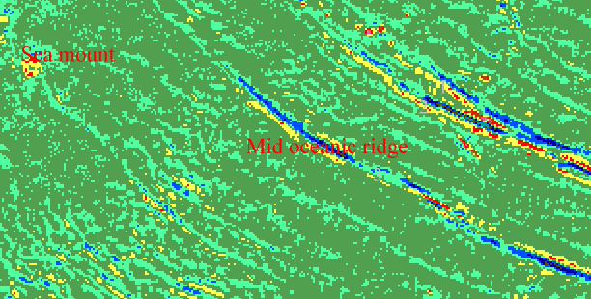
Representative image of the lesson:
Geosat image shows MOR and sea mounts

Module 5

Lesson title: Identification and Differentiation of Coastal Ecosystems
Module No. /Lesson No: M5/L1

Data key: Landsat TM
Location: South of Brazil
Classification key: Vegetation, coastal management

Connectivity: M3L3, M3L5, M4L1, M5L4, M6L3, M7L1, M7L2, M7L7 & M7L8

Aim: To use the Bilko systems for classification and analysis of the characteristics of the vegetation in a tropical coast, to establish zones and the succession of states following human activity.

Location and Data: The study zone is located in the south of Brazil (25 31-25 15 s and 48 45 – 48 20 w), and comprises one of the most important and clearly defined estuary lagoon systems in the country. This system is called “Estuario lagunar de Iguape-Cananeia y paranaua”, and is considered the third most important systems in the world in terms of primary productivity.
Channels 4 & 5 of the TM LANDSAT images are taken for the analysis.

Procedure: Images may be displayed. Channel 5 image may be selected as several zones may be better distinguished. Smooth filter can be applied for better observation of boundaries between the zones. Pixel values up to 98 can be masked to highlight the vegetation zones. This allows the differentiation of the variety of vegetation characteristics. Palette can be applied to the masked image to give particular colour to each vegetation zone and linear stretching to differentiate the zone. Mangrove area can be estimated using histogram option and areas of tidal influence may be enhanced using manual stretch.

Result: Mangrove constitutes the boundary of the terrestrial zone. In the centre, the tropical forests are found. Their characteristics being influences to some degree by human presence. The mangrove area has a surface area of 1,060 ha. Characteristic areas are classified as zones of marine influence like mud banks with or without salt marsh vegetation and mangroves, zones of marine river influence like transition vegetation; fresh water marshes, zones of river influence like forest of Atlantic influence. Values of radiance up to 42 correspond to the type of vegetation characteristics of the zones, which has experienced no significance human intervention. Mangroves like muddying banks with and with out vegetation of salt marshes, showing radiance between 8 and 21, mangroves between 22 and 35. Forest of Atlantic influence with or without anthropogenic influx shows radiance between 36 and 42.

Schematic Representation of the lesson:

Display of the images
Step I

Masking of images for differentiation of the vegetation characteristics
Step II

Step III

Application of the colour

Result

Identification of the mangrove, salt marshes and forest under Atlantic influence

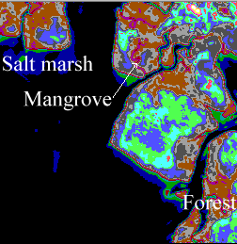
Representative image of the lesson:

Landsat TM image shows different habitats

Lesson title: Principal Characteristics of the Area Around Lagartos River, Yucatan, Mexico
Module No. /Lesson No: M5/L2

Data key: Landsat MSS
Location: Lagartos river
Classification key: Vegetation, coastal management

Connectivity: M3L3, M3L5, M4L1, M5L1, M6L3, M7L1, M7L2, M7L7 & M7L8

Aim: To identify and classify some of the main characteristics of the study zone using Landsat MSS image and the Bilko software

Location and Data: The estuary of the Lagartos River, located in the north-east of Yucatan state (co-ordinate 21⁰ 26 & 21⁰ 38 N and 81⁰ 38 W) in Mexico. Landsat MSS band 4, 5, 6 and 7 images are used.

Procedure: Images may be displayed for analysis. Different characteristics in images for each wave band may be seen more clearly using suitable palette and stretching. Image of band 5 may be masked for cloud and water by band 7 using radiometric masking. LUT and histogram options can be applied to the resulting image to highlight the characteristics of the area. Using two band ratioing and scatterogram supervised classification may be carried. Mangrove area can be delimited.

Result: Different characteristics of the area in the images for each wave band are identified and classified. Band 4 reveals movements of sediments and shallow areas; man made features that are salt highway also metropolitan areas and mine. In band 6 & 7 vegetation and boundary between land and water are seen more clearly. By masking clouds and water, mangrove, bare soil areas as beach and salt mine are seen.

Schematic Representation of the lesson:

Display of the images
Step I

Masking of cloud and water
Step II

Step III

Classification of image

Step IV

Delimitation of mangrove

Identification and classification of main characteristics like mangrove and bare soil areas

Result

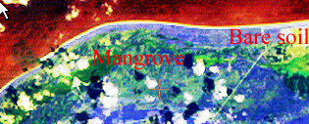
Representative image of the lesson:
Landsat MSS image shows mangrove areas and bare soil

Lesson title: Evolution of a Coastal Upwelling Event at 30⁰ S
Module No. /Lesson No: M5/L3

Data key: NOAA AVHRR
Location: Chile coast
Classification key: Upwelling, coastal management

Connectivity: M2L5, M4L2, M5L6 & M5L7

Aim: To study the evolution of an upwelling event of “Punta Legua de Vaca” Coquimbo, Chile, using a sequence of sea surface image and wind measurements

Location and Data: Los Vilas and Punta Lingua de Vaca, Coquimbo, Chile is the study area. NOAA- AVHRR channel 4 & 5 taken during 15th to 27th April 1992.

Procedure: Images may be displayed. Using linear stretch and masking the part corresponding to land, a map of sea surface temperature can be created. A graph representing the minimum and maximum temperatures reached during the days of strong winds can be made using histogram. Variation of the temperature from the coast to the open sea can be observed using transect option. Comparison of images can be conducted for seeing the evolution of the upwelling.

Result: The analysis of the data shows that the measurement period is characterised by a strong wind which began on the 22nd April and ended on the 25th of April. This shows marked diurnal cycles which, around sunset develop a surface drag in excess of 0.15N/m² along the coast, as can be inferred from the wind measurement at Punta de Toro and Los vilas stations. Winds perpendicular to the coast show weaker diurnal cycles and are mainly associated with the land-sea and mountain-valley breezes.

The upwelling event described occurs between two events of calm: 18th to 21st April and 26th to 28th April which are precede by another upwelling event between 15th and 19th April. The displayed images are more detailed and the cold water areas clearly distinguishable. The graph shows a progressive decrease of surface temperature in the areas near the coast, due to the rise of cold waters. The transect function makes it possible to follow the evolution of upwelling in the successive image. Progressive variation of the upwelling zone along the coast is also observed.

Schematic Representation of the lesson:

Display of the images
Step I

SST mapping
Step II

Step III

Graph of temperature against time

Step IV

Comparison of the images to observe upwelling zone

Evolution of the upwelling observed

Result

Representative image of the lesson:
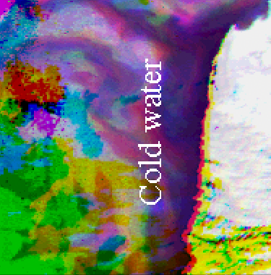
NOAA AVHRR image shows upwelling.

Lesson title: Observation and Analysis of a Red Tide Event from NOAA-AVHRR Images in the Argentinean
Module No. /Lesson No: M5/L4

Data key: NOAA AVHRR
Location: Argentina Sea
Classification key: Plankton, SST, coastal management

Connectivity: M1L4, M1L6, M2L2, M2L6, M4L1, M4L2, M4L4, M5L6, M5L9 & M6L1

Aim: To demonstrate the usefulness of the AVHR sensor in the study of extraordinary plankton blooming in Plate form waters, using the visible channel.

Location and Data: Argentina Sea is the study area. NOVA AVHRR channels 1,2, 4 and 5 (visible channel are used). The so-called red tides are variations in the colour of the sea water produced by extraordinary blooming of phytoplankton algae (Dinoflagelates from the genus Gyrodinium. The red tide present in this study occurred in the Argentina sea during the months of August and September of 1989.

Procedure: Temperature image may be displayed, using LUT and histogram option maximum and minimum values may be observed. Palette may be given to temperature image for better description of thermal structure. Setting white as the lower limit (cold) and brown as the upper limit (warm). Transect and cursor option can be used to characterise the surface thermal structure. Image for visual bands may be displayed for visual interpretation, differentiating between land, water with sediment on coastal zone and clouds. Clouds may be masked using radiometric masking, thermal gradient may be observed.
Cloud free zones may be identified and the zones of light penetration and red tide areas located. Land and clouds can be masked. The histogram of this image may be compared with the temperature-masked image to see the sea surface temperature structure clearly. Areas covered by red tide can be calculated from the DN values.

Result: Minimum and maximum temperature values are 0⁰C and 27.6 ⁰C respectively. The pixels with zero values are evidence of very cold elements, corresponding to the presence of clouds. Mean gradient is 4.6 ⁰C/ 6.6 Km. The distance from the coast to the nucleus of the Malvinas Current is 209 Km. The cloud free areas are seen as elongated structure in the centre of the image oriented parallel to the coast. Temperature image details a finer surface temperature structure. Small meanders and filamentous of the MC can be observed, which turn over the continental shelf. The areas covered by low, mean and high red tide concentration are 56216, 32290 and 10165 Km² respectively.

Schematic Representation of the lesson:

Display of the images of thermal and visible channel
Step I

Masking of the clouds and land
Step II

Step III

Detection of red tide and penetration zone

Step IV

Comparison of the images

Thermal structure patterns and red tide blooms are observed.

Result

Representative image of the lesson:
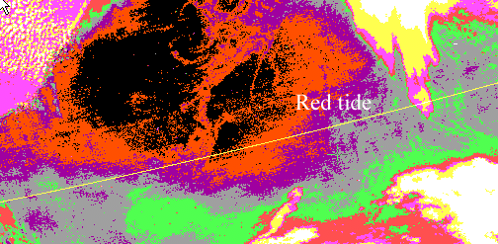

NOAA AVHRR image shows red tide
The oblique line appears in the image arise from errors during acquisition of the satellite information

Lesson title: Research on Physiographic Phenomena Influenced by Marine Current in the Terminos Lagoon
Module No. /Lesson No: M5/L5

Data key: Landsat TM
Location: Gulf of Mexico
Classification key: Current, coastal management

Connectivity: M4L1

Aim: This lesson illustrates some of the procedure used for the indirect identification of the geo morphology of shallow water basins, and the movements of water masses in coastal lagoon.

Location and Data: Terminos lagoon located south of the Gulf of Mexico, between 91⁰ 15- 91⁰ 51 W and 18⁰ 27- 18⁰ 15 N is the study area. Landsat TM bands 1, 2, 3, 4 taken on April 3 1991 are used.
To the north of the Lagoon there is a barrier forming Carmen island and is bordered by two big mouths: The Peurto Real Mouth is strongly influenced by transparent marine water which form a notable inner delta with shoals and channels. The Carmen mouth is influenced by the Palizada river which had abundant suspended terrigeneous contributions. These produce great turbidity and contribute to the formation of an outer delta.

Procedure: Images may be displayed with suitable palette. The flow of current can be identified at the Peorto Real current. Land can be separated from water using linear stretch. Radiance values of water can be determined using histogram. Comparison can be conducted between the prestretched and stretched colour image. Using default, palette and applying histogram equalisation to thermal band image, temperature of the thread an be determined. Filter can be used to band 1 image. Palette, LUT and can be applied to show the geomorphology of shallow waters. Filtered may be compared with the unfiltered image. To identify the vegetation zone, NDVI zones can be applied to band 1 and 4.

Result: In the image, the current that enters the lagoon and forms the inner delta can clearly be seen also the flows formed by the different marine current that enter the mouth of the Peorto Real are visible. A thread of water may be also observed leaving Sabancuy estuary. This has a different density and temperature from marine water. The radiance ranges of the water for the band 1, 2 and 3 are between 78 to 163, 29 to 73, 15 to 58 respectively. In the stretched image, it may be seen that the current reaches the thread of water in the estuary. The marine water crosses over the thread, but is stopped by the discharge of the Candelaria river. The thermal band image shows that the thread of water leaving the estuary has a different temperature from the remaining zones which are rarely homogeneous. The applied filter enhances boundaries and shows the geomorphology of the shallow waters. The delta is well defined as are the channels formed by the constant flow of water entering the Peorto Real mouth, and the coastline. The boundary of the water masses of different salinity can also be detected, as can the thread of water in the estuary. The filtered image after using palette and LUT default, fully separated boundaries between land and water, the details of the lower systems of the intertidal deltas can be identified. Analysis of the band 4 image shows that the zones of vegetation can be distinguished clearly from the zones of bare soil and from urban zones.

Schematic Representation of the lesson:

Display of the images
Step I

Separation of land and water areas using linear stretching
Step II

Step III

Observation of water masses movement

Step IV

Enhancement of image for showing geomorphology of shallow areas

Identification of the flow of water masse in the lagoon

Result

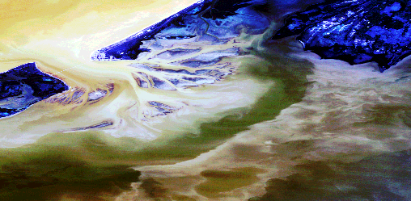
Representative image of the lesson:

Landsat TM image shows the flow of water masses in the lagoon

Lesson title: Thermal Structures Associated with Superficial General Circulation Observed Between Cape Verde and Freetown (North West Africa)
Module No. /Lesson No: M5/L6

Data key: NOAA 9 AVHRR
Location: Western Coast of Africa
Classification key: Upwelling, SST, coastal management

Connectivity: M1L4, M1L6, M2L5, M2L6, M4L1, M4L2, M4L4, M5L3, M5L4, M5L6, M5L7 & M6L1

Aim: To use a time series of NOAA images to demonstrate thermal structures and establish an approximation to the seasonal variation of the superficial circulation: to relate the daily fluctuation of such structures to a relaxation event from the upwelling at Cape Verde.

Location and Data: The area of the study is the western coast of Africa between Cape Verde (Senegal) and Freetown (Sierr Leone). Six SST images from the AVHRR sensor on the NOAA 9 satellite images area used.

Procedure: Images may be displayed and palette applied to highlight the thermal structures. Histogram and cursor options may be used to differentiate the temperature zones. Stretch may be used to neglect the values correspond to the land and clouds and to visualise the variation in the sea. LUT may be applied and images may be saved. Radiometric masking can be applied to mask the land and cloud pixels. Image may be enhanced using linear contrast enhancement. This image showing sea pixels may be saved. The images may be compared and differences can be observed. Using transect function to the saved image the evolution of the temperature in February can be observed and orientation of iso therms may be observed for studying upwelling. A common transect along the palette form may be used and digital values of each points can be used to calculate the differences along the defined transects.

The magnitude of the SST anomalies of Cape Verde may be calculated. Spatial evolution of the isotherms during the year can be established using transect on a line parallel to the coast in a north east direction.

Result: In the images the temperature gradients are clearly defined. The temperature interval (between 17 ⁰C and 29 – 30 ⁰C) has its warmest points in the tropical waters located in the south of the image. Upwelling event in south of Cape Verde can be seen. The sea temperature on selected digital interval ranging from 136 and 240 is to be 17 ⁰C and 13 ⁰C respectively. Colour image shows temperature gradient clearly representing the warmer tropical waters located south of the images. The thermal structures of the sea surface waters vary according to the intensity of the upwelling. In the original image the observed values are much higher than in those resulting from the LCE process. Temperature patterns are logically similar, but, as a result of the histogram enhancing process, they appear more detailed in the final image. The thermal anomalies (the SST anomaly are established in coastal waters and waters of open sea) calculated from images -5.5 and –4. These show the existence of a coastal upwelling event. The orientation of thermal structures perpendicular to the coast shows the absence of upwelling.

The thermal structures of the 6 images show common characteristics. The spatial distribution of these structures shows the existence of a coastal counter current directed toward the north. This gains strength in the beginning of the year and reaches its peak value in the summer.

Schematic Representation of the lesson:

Display of the images
Step I

Observation of thermal structures
Step II

Step III

Radiometric masking land and cloud

Step IV

Seasonal study of isotherms during the year

The thermal structures of the sea surface water vary according to the intensity of the upwelling

Result

Representative image of the lesson:
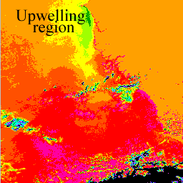
NOAA 9 AVHRR image shows upwelling event.

Lesson title: Monitoring the Coastal Upwelling NW of Africa with AVHRR-APT Images
Module No. /Lesson No: M5/L7

Data key: NOAA-11 AVHRR
Location: North-West Coast of Africa
Classification key: Upwelling, SST, coastal management

Connectivity: M1L4, M1L6, M2L5, M2L6, M4L1, M4L2, M4L4, M5L3, M5L4, M5L6 & M6L1

Aim: To use APT images from the AVHRR sensor for characterization of upwelling events on the North West Coast of Africa.

Location and data: North-West coast of Africa. Two Automatic Picture Transmission (APT) images (band 2 & 4) of AVHRR sensor boarded on NOAA-11 satellite.

Procedure: Band 4 image is to be loaded. North-west coast of Africa is visible on the right and next to it, the Canary Archipelago may be seen to the north. Applying linear stretch land and clouds can be masked. Clear pixels showing low temperature can be observed near the coast that become more progressively darker moving towards the sea.

Subscenes of both the bands with the maximum possible resolution can be selected and saved. Then using the scatterogram option supervised classification of the spectral characteristics of the image can be performed. Training polygons like rectangles on land, in the core of the upwelling, in the edge of cloud and in the cloud core can be located. Sketches of positions of these classes can be made in the dispersion diagram.

Parameters corresponding to the NOAA-11 satellite, band 4 may be used to get a relation (From Plank's equation) for obtaining SST. Using the relation an apparent SST in the scene may be obtained. It is called apparent because, the atmospheric effects had not been corrected. Multiband and multiview algorithms could be used for the correction.

For the detection and quantification of upwelling, surface thermal anomaly index is used.

Low pass filters may be applied to the image for reducing the noise. The field of surface temperature appears very homogeneous. There is no sharp changes in the brightness values.

Result: Low temperature waters lie mainly closed to the coast and are stratified parallel to the coastline. This indicates upwelling. Farther from the shore the temperature increased and the stratification disappeared.

It can be observed that the characteristic of the cloud boundaries is similar to those of the upwelling core and the classes are not easily separated by the simple observation.

The value of surface thermal anomaly index in the Canary Island and near Dakhli is 3 ⁰C.
The transition between colder waters and warmer waters are more evident especially in the zone of Cape Bojador and south of Tenerife Island.

Schematic Representation of the lesson:

Display of the images
Step I

Classification of spectral characteristics of image

Step II

Step III

Estimation of SST

Step IV

Visual enhancement

Identification of upwelling using SST front

Result

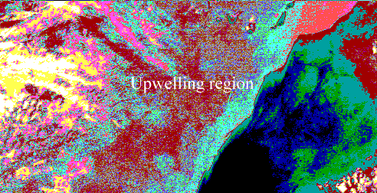
Representative image of the lesson:

Image showing SST fronts

Lesson title: Study of the Distribution of Suspended Solids in the Western Coast of Maracaibo Lake (Venezuela), Using Landsat Data
Module No. /Lesson No: M5/L8

Data key: Landsat TM
Location: Maracaibo Lake
Classification key: Suspended load, coastal management

Connectivity: M1L3, M1L5, M2L3, M3L1 & M4L5

Aim: To experiment with the use of contrast enhancement by separation into ranges of the image grey level values over body of water.

Location and Data: Maracaibo Lake located in the western region of Venezuela between 9⁰ 00 and 10⁰ 30 N and 71⁰ 00 and 72⁰ 20 W. Landsat TM channel 2 and 3 are used.
The main source of the sediment is the Catatumbu River.

Procedure: Image may be displayed with different palette like VGA and EGA. Stretching can also be conducted. Histogram equalisation can be applied for more contrast. This may be helped to distinguish several solid distribution patterns. Different ranges of pixel values corresponding to different relative suspended solids can be created using cursor and palette option. Comparison of images obtained by the EGA palette and that result from the manual stretch can be made.

Result: Image is not visible with VGA palette. The EGA palette provides much detail of the image. Linear stretch function controls the minimum and maximum values in the radiometric response. This allows an improvement in the contrast of the image by redistributing the pixel values in the adjusted histogram. Different solid patterns are seen. The behaviour and distribution patterns of solids along the coast of lake are distinguished. After comparing the image it is concluded that it would be possible to observe the finer differences in the solid content only if more ranges of colours are selected. The images of band 2 and 3 show a similar distribution of suspended solids with only minor difference.

Schematic Representation of the lesson:

Display of the images
Step I

Application of VGA and EGA palette
Step II

Step III

Identification of suspended solid distribution pattern

Step IV

Comparison of the images

Observation of the similar pattern of distribution of suspended solids in both the bands

Result

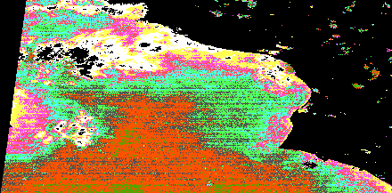
Representative image of the lesson:
Landsat image shows suspended solids

Lesson title: Identification of Physical Processes Favouring the Development of Phytoplankton, Based on the Colour Characteristics of the Sea.
Module No. /Lesson No: M5/L9

Data key: CZCS Nimbus 7
Location: Atlantic Ocean, Caribbean Sea
Classification key: Phytoplankton, coastal management

Connectivity: M2L2 & M5L4

Aim: To demonstrate the use of the CZCS sensor to register ocean dynamics over vast areas at the same time, by using the colour variation of the sea as modified by phytoplankton, suspended matter and dissolved organic compounds.

Location and Data: Study area extends from the northern coast of the South American continent, including part of the north equatorial western Atlantic Ocean and the south of the Caribbean Sea. CZCS Nimbus 7 satellite image of four areas is utilized for this study.

Procedure: Image representing areas of west Venezuela, may be displayed. Histogram may be applied to the image to show the pixels corresponding to the land, missing data and cloud. Suitable palette and manual stretch may be used to assign white colour to pixels with values 255 and black to 0 pixels. Remaining pixel values represent the pigment concentration. Their identification can be made using LUT colour option. Image may be saved.
Image of Atlantic Ocean, Central zone of Venezuela and Gulf of Venezuela may be displayed. Using palettes comparison may conducted with saved image. Since cloud is observed in all the images, it is necessary to pick out the boundaries a map. Based on the previous knowledge of oceanography of area of analysis of the image, causes or even explaining the presence and form of dispersion of pigment patch may be conducted.
In the image of West Venezuela, the plume of Orinocon River may be seen clearly. Colour of the sea may be used to track the trajectory of the plume. Concentration pigment fronts may be seen by transect and enhanced using gradient and histogram equalization option. The image of central zone of Venezuela shows the concentration of phytoplankton is very low except in the proximity of Cape Codera. Pigment concentration and dispersion patterns can be also observed.

Result: In image of west of Venezuela occupies the lower part of the image and it is possible to distinguish the two gulf, the Peria and the Cariaco gulf. Margarita Island lies a little more to north close to the continent and almost completely covered by clouds. Plume of the Orinoco River enters the Caribbean Sea through the strait of Bocade Daragon between the continent and Trinidad Island, visible in the bottom of the image. This plume is directly toward the northwest. This trajectory can be explained as a result of the forces Acting on the surface waters. The area under study is located in the northern hemisphere, so the river plume should deviate to the right, but because this is near the equator Coriolis force is small. In this case, the geo strophic towards the west dominate over the force due to earth rotation. Only occasionally does the Orinoca discharge in to the Atlantic, when atmospheric and marine current changes are produced on a big scale. The patch present in Cape Codere is considered to be the result of local upwelling, since it appears for short time intervals and coincides with wind maxima. Here again the shape of the depression is the result of the effect of the eastward wind and the westward current. In the image of the Gulf of Venezula, a depression pattern that indicates the presence of an event, probably physical, that favours the primary producers .This concerns the plume that form to the north of and continue towards the north west of the Paraguna peninsula. The mechanisms favouring the increase in phytoplankton production in this place are not known. This kind of depression has not previously been recorded, because there are too few pigment measurements in the area. It is thought that there could be a kind of vertical fertilization due to the effect of a geostrophic current in the border of the plat form. This idea is based mainly on the fact that the plume in the east flows the boarder o f the continental platform..

Schematic Representation of the lesson:

Display of the images
Step I

Comparison of images
Step II

Step III

Detection of the trajectory of the plume using sea colour variation

Result

Identification of pigment concentration fronts and dispersion pattern

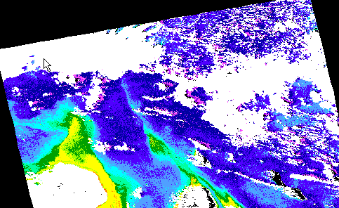
Representative image of the lesson:

Image showing pigment concentration

Module 6

Lesson title: Deriving Sea Surface Temperature Maps from the ERS-1 Along Track Scanning Radiometer
Module No. /Lesson No: M6/L1

Data key: ERS-1 ATSR
Location: West Coast of Japan
Classification key: SST, coastal management
Connectivity: M1L4, M1L6, M2L6, M4L1, M4L2, M4L4, M5L4 & M5L6

Aim: The aim of the lesson is to demonstrate the methods used to derive sea surface temperature maps from ERS-1 Along Track Scanning Radiometric brightness temperature image data

Location and Data: West Coast of Japan is the study area. Data images used in this study are 10.8 micron and 12 micron nadir and forward look ERS-1 ATSR/1 brightness temperature data. The images were acquired on the 25th April 1992 at 12:25UT.

Procedure: Image of 10.8-micron nadir may be displayed. Identification can be conducted for the main features. Histogram can be prepared and peaks shown in the histogram may be identified. Transect option can be used to pick out features. For the purpose of defining the ATSR across track bands image masking may be conducted. A binary image with maximum value 1 and minimum value 0 can be connected with ATSR 10.8-micron image. A formula document, which multiplies the two images, may be applied to the connected image. The new image may be analyzed.

The next step is the derivation of the nadir SST image. As a first stage a difference image may be prepared from 12 and 10.8 micron nadir images scaled so that DN value of 128 is equal to zero. Study can be made on the image. For deriving a nadir SST image, a formula document can be prepared and applied to the connected images of 10.8, 12.0-micron and 5 mask images. The new SST image can be compared with the 10.8 nadir image. Next step is the derivation of a dual look SST from the ATSR/1. Images of 10.8 micron and 12.0 micron forward and nadir brightness temperature images may be compared. A difference image of 12.0 nadir and 12.0 forward can be prepared. Images of forward and nadir 10.8, 12.0 micron and 5 image mask documents can be connected and a formula containing equations for the dual SST image may be applied to the connected image. Comparison can be conducted for the nadir SST image and the dual SST image.

Result: The Kuroshio water current, Oyashio water current and its mixing regions with cyclonic eddies are visible in the images

In the difference nadir images, attenuation of the nadir leaving radiance by atmospheric water vapour is higher than in the 10.8 and 12.0 micron data. The values in this image represent the temperature contribution made by the atmospheric integrated absorption and emission as the water leaving radiance passes through the atmosphere. This image graphically shows the fundamental basis of the multi-channel sea surface temperature algorithm. The main difference shown by the SST nadir data is that SST data are warmer than the brightness temperature data as the cooler emission associated with atmospheric absorption and emission have been corrected for by the SST algorithm.
The forward look image shows some difference from nadir looking image, as forward field of view is larger than the nadir reducing the spatial resolution. Forward view image is significantly cooler than the nadir image as a consequence of the increased atmospheric absorption through longer atmospheric path length.

The dual SST image makes a superior choice because it utilizes the direct measurement of the atmospheric absorption and emission characteristics. A difference map of these two images clearly demonstrates that the nadir SST is > 3 C cooler in some instances.

Schematic Representation of the lesson:
Display of images and identification of main feature
Step I

Preparation of nadir only multi-channel SST
Step II

Derivation of dual look SST image
Step III

Result

It is observed Kuroshio, Oyashio current and also it’s mixing

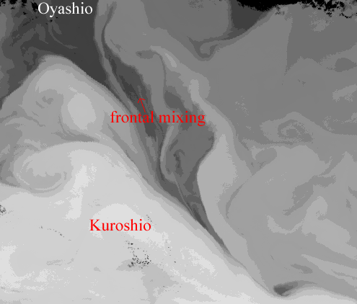
Representative image of the lesson:
ATSR image shows the Oyashio and Kuroshio current and its mixing
Lesson title: Using Landsat for Coastal Management-1: Mapping and Determining Major Substrate Categories.
Module No. /Lesson No: M6/L2

Data key: Landsat TM
Location: Red Sea
Classification key: Habitat, coastal management
Connectivity: M3L2, M7L1, M7L2 & M7L6

Aim: The lesson seeks to show how various images processing techniques can aid in the interpretation and optimal display of a multispectral satellite image. It illustrates the initial stages of mapping a remote and rarely visited inaccessible coastline. This mapping includes estimating the locations of important features such as coral reefs, the exact shoreline and the major terrain types.

Location and Data: The study area is a desert coastline along the Red Sea. Bands 1-4 of the Landsat TM images of the study area are prepared for the analysis.

Procedures: To demarcate the land and sea a true colour composite can be prepared. For this purpose stretched blue, green and red bands can be taken. Since stretched one will not retain the original pixel value original images can be combined. An investigation can be made for deep water, shallow water and land pixels. It is recommended to compare the values of these pixels with infra red band. Since it is very difficult to separate land from sea pixels on the basis of reflectance in band 1, a binary mask can be created using IR image. A formula document may be used to mask with all land pixels set to 1 and all sea pixel set to 0 and can be applied to the connected images of 1 and 4. Applying one high pass filter, which will enhance the sharp change in pixel values, can also identify land-sea boundary. Various stretching like Guassian and filtering like Leplacian high pass filter can be applied to note clearly the land-sea boundary.

Result: The original image of blue band doesn’t show the coastline clearly because, the blue-green light which is measured in this wave band reflects nearly as strongly from the sea bed through shallow water as it does from the surrounding dry land. The histogram of the IR image is bimodal because, the part of the image is sea, part is land and these two substrates have major differences in reflectance characteristics in the near IR band. In the blue band image, deep sea showed non-zero value, because there is dust in the air, which reflects infra-red in the pixels over the sea. Before applying binary mask land-sea boundary was in the DN range of 55 – 65. After applying mask and by stretching land sea boundary at 80, much of the land is masked out with the shadowed areas below the escarpment being classed as sea. The most obvious effect of setting the land sea boundary at 50 is that the offshore coral reefs are classed as land. After applying high pass filters it is not nearly possible to tell exactly where the land sea boundary is. After applying different filters it is seen that weighted filter is more gentle removing speckle with little loss of other information. After the application of Gaussian stretch to the images of IR band, clearest boundary is revealed. The boundary is visible on the red image and just visible on the green wave band image. The Leplace filter gives the land a three dimensional aspect so that it is able to see the relief of the terrain.

Schematic Representation of the lesson:
Step I

Preparation of the true colour composite with blue green and red

Step II

Comparison of the image with IR

Step III

Creation of binary mask

Step IV

Application of high pass filter and stretching

Step V

Application of Leplace filters

Observation of coral reefs to the bottom right of the image
Result

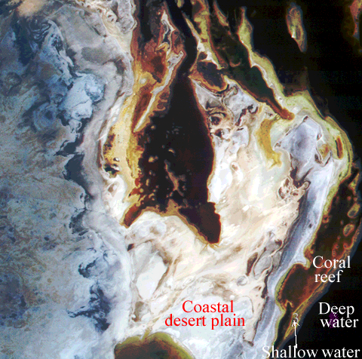
Representative image of the lesson:

Landsat image shows different features

Lesson title: Using Landsat for coastal management-2: Vegetation mapping.
Module No. /Lesson No: M6/L3

Data key: Landsat TM
Location: Red Sea
Classification key: Vegetation, coastal management
Connectivity: M3L3, M3L5, M4L1, M5L1, M5L2, M7L1, M7L2, M7L7 & M7L8

Aim: The lesson develops simple classification procedure to illustrate how vegetation can be identified on Landsat image, and how the image areas of vegetation in the image can be quantified.

Location and Data: The study area is a desert coastline along the Red Sea. Bands 1-4 of the Landsat TM images of the study area are prepared for the analysis.

Procedure: As a first task a false colour composite using 2, 3 and 4 bands of TM may be prepared to show where there are patches of vegetation. Before doing this each image may be stretched to improve the contrast. Identification can be done for vegetation and area with photosynthetic pigment. The FCC may be saved. In order to inspect the spectral signature of various habitat on colour composite of the above bands can be prepared but without stretching. Investigation can be done for shallow water pixel, land and vegetation pixels. To enhance the vegetated areas, calculation can be made for NDVI from red and IR band. Stretching can be conducted for getting a better result. Histogram of the stretched image may be prepared. Comparison can be made between this image and the saved FCC image. From NDVI image it can be possible to estimate the total area of mangrove. For this histogram option can be used. It can be noticed that the indicator of emergent vegetation like algae, coral zooxanthella are present along the top of the barrier reef. Study can also be made for how much of the total land area is vegetated. For this image of land mask can be used.

Result: 4 classes of vegetation are identified in the colour composite as Mangroves 1, Mangrove 2, algal mat and Sargassum. In the NDVI image, pixels with vegetation are more reflective in the near IR than in the red. In the unvegetated areas pixels tend to have higher reflectance in the red than IR and thus appears as dark in IR/red ratio. Inspecting the histogram of the stretched NDVI image it is found that the mangrove area is of 83 ha along with 471 ha assumed to have significant vegetation cover. The land area estimated is of 15,377 ha and the area of land with significant vegetation cover represents 3.1% of the total land area.

Schematic Representation of the lesson:

Step I

Preparation of stretched and unstretched false colour composite

Step II

Identification of vegetation and area with photosynthetic pigment

Step III

Preparation of the NDVI

Step IV

Calculation of the vegetation area

Mangroves, algal mats and Sargassum habitats are observed.
Area of land with significant vegetation cover represents 3.1% of total area

Result

Representative image of the lesson:
Landsat TM image shows different features

Lesson title: Imaging Coastal Features with ERS-1 Synthetic Aperture Radar; Central English Channel
Module No. /Lesson No: M6/L4

Data key: SAR image of ESA ERS-1
Location: English Channel
Classification key: Surface features, coastal management
Connectivity: M1L7

Aim: To demonstrate a variety of ocean surface phenomena, which can be imaged by synthetic aperture radar (SAR) in a coastal region.

Location and Data: English Channel and its adjacent isles of Wight is the study area. SAR images from the advanced microwave instrument flown on ESA ERS-1 are taken for the study.

Procedure: The SAR image may be displayed. Land and sea can be distinguished. Image may be stretched to reveal the sea surface pattern. Histogram can be prepared and an interesting toe can be noted at low values. Identification and study of different types of features can be tried which appear on the sea in the different part of image. Texture, tone etc can be taken into consideration for the identification.

Result: In the image, features like sheltered coastal region, surface slick patches, fine scale slicks, ship tracks, ocean swell waves and signature of bathymetric features are visible. Coastal areas appear as dark zones. The most likely causes of a very smooth sea surface giving zero backscatter are either that the wind is zero or too weak to roughen the surface, or else that there is a film of surfactant material which prevents the relatively light wind from generating the short waves which the radar sees as roughness.

Surface slick patches are seen as a dark patch with sharp edges. It has got a sinuous shape due to the fact that the slick zone appears to have started as an elongated form, which has since been subject to current shear.

Linear streaks area seen in the lower half of image a narrow streaks with one or two pixels wide. It is not able to say the exact cause, but it is likely that they are the result of linear pattern of local convergence, which show surfactant material into lines of the sea surface.

The fine slick lines are visible in Christchurch and Bournemouth Bay with pixel strength about 40. They may be relics of river plumes, which have discharged into the bays, leaving a slick line along the river out flow front.
In the English Channel, larger vessels show up as bright pinpricks of strong backscatter. It shows the characteristic V- signature associated with the ship generated wave field, which indicates the direction of the travel.

After applying Gaussian stretch ocean swell waves are visible as quasi-regular stripes of light and dark running approximately up and down the image, The wavelength of this is approximately 400m.

The bathymetric spectrum contains both higher and lower values of backscatter than the area. The brighter areas imply that wave energy is being concentrated. Signature of bathymetry normally be detected by the high levels of backscatter encountered, the texture and additional knowledge of shallow region.

The probable reason, why so many features appear on this image is that the winds are relatively light and so there are quite sharp transitions evident between backscattering zones and those, which are smooth

Schematic Representation of the lesson:

Display of the image
Step I

Stretching of the image

Step II

Identification of sea features
Step III

Result

Observed features like, sheltered coastal regions, surface slick patches, fine scale slicks, ship tracks, swell and signatures of bathymetric features

Representative image of the lesson:
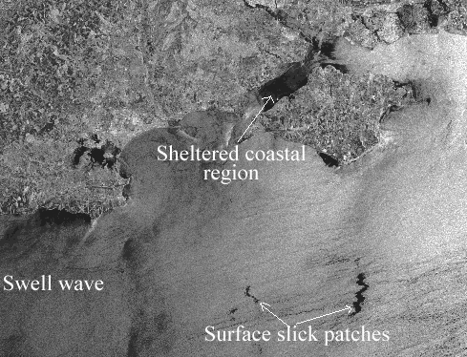
SAR image of ESA ERS-1 shows different features

Module 7

Lesson title: Visual Interpretation of Images with the Help of Colour Composite: Getting to Know the Study Area
Module No. /Lesson No: M7/L1

Data key: CASI, SPOT XS
Location: Caicos Island
Classification key: Habitat, coastal management
Connectivity: M3L2, M6L2, M7L2 & M7L6

Aim: Identification of mangrove habitats of south Caicos Islands and some marine habitats in Cockburn harbour.

Location and Data: The study area is the Turks and Caicos Islands to the south-east of Bahamas. Imageries of CASI & SPOT XS are used for the study.

Procedure: Green, Red and IR bands of the SPOT imageries may be displayed. A false colour composite of the image may be prepared. Experiment can be done with different stretching to display the colour composite to full advantage. Visual interpretation can be done to examine the mangrove zonation and marine habitat. Prestretched FCC of Cockburn Harbour take in the CASI may be displayed. Many reef habitats can be identified in this image. For identifying different marine habitats zooming in and out can be conducted. A study can be conducted to know the use of visual interpretation when planning the field survey.

Result: In the SPOT FCC image mangroves are seen as a bright red belt along the west coast of island. Bright red colour of mangrove is due to high reflectance. In this mangrove belt, short red mangrove (Rhyzopora mangale) is identified near the water edge. Tall black mangrove (Avicinnia germanians) are seen away from water edge and short scrubby white mangrove Laguncularia racemosa) which is visible on higher ground and interspersed with non mangrove vegetation.

Submerged habitats like dense sea grass bed of Cockburn harbour could be identified to the south east of the mangrove habitat. Dense sea grass bed looked very dark because it has generally low albedo and bare sand area where shown as bright areas.

In the CASI image of the Cockburn harbour many reef habitats are identified. Brown algae (Lobophora variegata) is identified near the shore line. Large coral heads are identified as large patches surrounded by paler sand or sea grass. Large stands of elkorn coral (Acropora palmata) are visible in shallow areas. Montastraea reef is seen associated with the outer fringing reef. Gorgonian plain is seen associated with bare substratum with a high reflectance. Dense sea grass (Thalassia testudinum) shows a distinctive green colour with sharp boundaries. Sparse sea grass also seen as green but the tone is more luminescent than dense seagrass with indistinct boundaries. Blowout sea grass is visible as elliptical areas in the sea grass bed.

Schematic Representation of the lesson:

Display of SPOT XS and FCC of CASI images
Step I

Preparation of FCC of the SPOT XS images

Step II

Visual interpretation of the images
Step III

Result

Mangroves, reef habitats like Acropora, Montastraea and algae like Labophora, etc are seen

Representative image of the lesson:
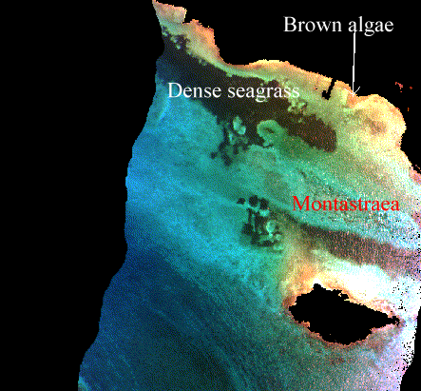
CASI image shows the sea grass and reef habitats

Lesson title: The Importance of Acquiring Images of the Appropriate Scale and Spatial Resolution for your Objectives
Module No. /Lesson No: M7/L2

Data key: CASI, SPOT Pan, SPOT XS, Landsat TM and Landsat MSS
Location: South Caicos, Turks and Caicos Island
Classification key: Habitat, coastal management
Connectivity: M3L2, M6L2, M7L1 & M7L6

Aim: To demonstrate the effects of image spatial resolution (ranging from 1 m to 80 m) on the ability of images to discriminate between different coastal habitats.

Location and Data: The area studied here is sea grass, mangrove habitat and coral reefs of South Caicos, Turks and Caicos Island. For the present study imageries of CASI, SPOT Pan and Landsat MSS are used.

Procedure: For comparing the spatial resolution of the imagery images of 3 spectral resolution viz. CASI (2m), SPOT Pan (10 m) and Landsat MSS (80m) taken from South Caicos region can be displayed. Estimating the width of the runway at South Caicos airport can be done by recording the number of pixels that cross the runway and then multiplying this by the width (in m) of each pixel.

For mangrove mapping CASI, SPOT Pan and Landsat MSS images containing Mangrove on the west cost of South Caicos can be displayed. Diameter of the circular patch of Rhyzophora lying just offshore can be estimated with the help of transects function. From the diameter, area can be calculated. Area of the fringing mangrove can also be calculated. Since it lies diagonally, Pythagorus theorem can be used to estimate the area. This can be repeated for three images.

Spatial frequency of sea grass and coral features may be conducted with CASI image (1 m). For this recognition of the features can be conducted and then width also may be done. This knowledge of spatial frequency can be used to predict the presence of the features in various types of images.

Inorder to take the advantage of considering habitat texture when interpreting remotely sensed imagery SPOT XS used for mangrove mapping and aerial photography of spatial resolution (2 m) can be used. Different patches may be seen. Identification can be done which patches are coral and which patches are sea grass based on their colour and texture.

Result: Runway of South Caicos is clearly seen in CASI, visible in SPOT, but not as clear as in CASI and in Landsat MSS it is very difficult to see the runway as it is similar to the spatial resolution of the sensor.
Two types of mangroves are seen in the image-containing mangrove, which are linear fringing mangrove and circular red mangrove. It is highly visible in CASI but with less detail in SPOT image. In the Landsat MSS Rhyzophora are not visible. But the fringing mangrove is just visible as a strip of 1-2 pixels.
Three habitats, sea grasses blow out, dense sea grass beds and colonies of coral Montastraea sp. are identified in the CASI. The same features are seen in aerial photography, but in SPOT Pan coral colonies are not visible and in Landsat only seagrass are visible. Largest blow outs are seen in SPOT Pan but smaller ones are not appeared as its size is right on the boarder lines of the spatial resolution of the SPOT Pan.
Sea grass bed shows a fairly uniform texture where as coral reef show a patchy structure. The sea grass beds are uniformly dark whilst reef areas are lighter and varied structure

Schematic Representation of the lesson:

Step I

Display of the images of CASI, SPOT Pan and Landsat MSS

Step II

Comparison of spatial resolution

Step III

Mangrove mapping

Step IV

Spatial frequency estimation of seagrass and coral features

Comparison of texture of seagrass beds and coral reef patches

Step V

Result
Recognition of features like mangroves, seagrass and coral reefs

Representative image of the lesson:

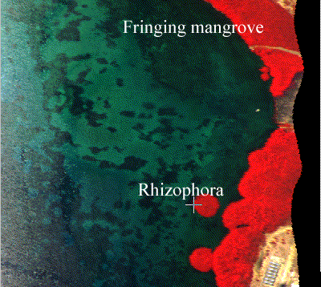
CASI image shows Sea grass and fringing mangrove

Lesson Title: Radiometric Correction of Satellite Images: When and Why Radiometric Correction is Necessary
Module No/Lesson No: M7/L3
Data key: Landsat 5 TM
Location Key: Turks and Caicos
Connectivity: Radiometric correction, simulation
Classification Key:

Aim: To carry out the radiometric correction of imagery using two Landsat TM images obtained at different seasons under different atmospheric conditions

Location and Data: Turks and Caicos Islands are the study area. Two Landsat 5 TM data taken on 22nd November and 22nd June 1990 are used for the study.

Procedure: True colour composite of 22nd November and 22nd June 1990 may be displayed. The five sites viz deep water, sand in very shallow water, mangrove, coral reef and seagrass. A formula may be applied for converting DN of selected five sites to spectral radiance. Spectral radiance can be converted into atmospheric reflectance using another formula. Atmospheric effects, absorption and scattering may be removed by atmospheric modeling method using the 5S Radiative Transfer Code. The inversion coefficient and spherical albedo may be calculated from 5S code out put. The inversion coefficient and exo-atmospheric reflectance data can then be combined using formula document to implement the modal inversion to the imagery. Comparison of surface reflectance values at selected five sites in the corrected June and November may be conducted using formula. The absolute difference between each of the five parts of DN may be calculated using spreadsheet.

Result: It is found that Landsat TM4 DN value for deep water and for the coral reef and sea grass areas were the same. It was due to the fact that red band penetrate poorly so that by about 5 m deep even bright sand is not likely to reflect any more light back than the deep water. The sea grass area had a very low albedo and being thick vegetation had a low reflectance in the red wave band. Thus this area reflect no more red light than deep water. The coral reef area also had low reflectance in the red band due to the presence of zooxanthella in the coral tissues and was also probably too deep to reflect more red light than deep water areas.

The 5S Radiative Transfer Code model predicts the apparent exo-atmospheric reflectance at the top of the atmosphere using information about the surface reflectance and atmospheric conditions. After comparing the uncorrected data of June and November, it is observed that because of the extra haze in the atmosphere in June none of the coming sunlight is reflected back at the sensor, making the whole image brighter with higher DN values at all pixels. Once the atmospheric corrections have been made for, then images appear more remarkably similar with pixel values almost identical. The average absolute difference between November and June band 1 DN values expressed as a percentage of the average of the 10 DN values is 25.19 %. The average absolute difference between the November and June TM band 1 surface reflectance may be expressed as a percentage of the average of the ten values is 2.96 %.

Schematic Representation of the lesson:

Display of the images
Step I

Conversion of DN values into spectral radiance
Step II

Conversion of spectral radiance to exo-atmospheric reflectance

Step III

Comparison of the images
Step IV

The average absolute difference between the November and June TM band 1 surface reflectance are expressed as a percentage of the average of the ten values is 2.96 %.
Step IV

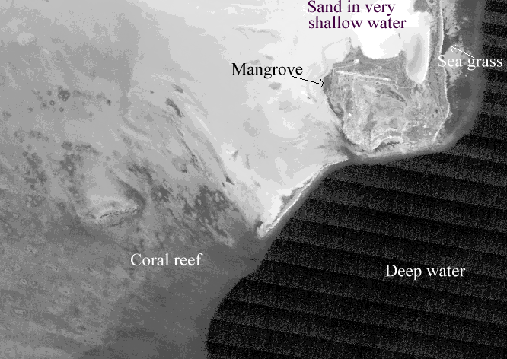
Representative image of the lesson:
Landsat TM image shows different features

Lesson title: Crude Bathymetric Mapping Using Landsat TM Satellite Imagery
Module No/Lesson No: M7/L4
Data key: Landsat TM
Location Key: Turks and Caicos
Connectivity: Bathymetry, coastal management
Classification Key: M5L5 & M7L5

Aim: To learn how bathymetry can be mapped crudely from digital imagery and the limitations of the results.

Location and Data: Turks and Caicos Banks is the study area. Images of Landsat 5 TM on 22nd November at 14.50 hrs UT are taken for the study.

Procedure: The first step is to find out the maximum and minimum pixel values over deep water. Images of bands 1 to 4 may be displayed and maximum, minimum and mean values can be estimated by copying a block of deep-water pixels to a spreadsheet or by histogram method.
Next step is to estimate the maximum depth of penetration for each wave band. UTM coordinate referenced field survey data can be used for this. Combining the data of DN values of deep-water pixels and the maximum depth of penetration, construction of a decision tree can be conducted for assigning pixels to depth zones. For implementing a decision tree a formula document and a landmask image which separates land from very shallow water are needed. Formula may be such a way that it creates a mask where pixels in a Depth of penetration (DOP) zone are coded to one and pixels outside the depth zones are coded to zero. Formula can be applied to the connected images of TM 1 to 4 and landmask image. Inspection can be made to the four DOP zone mask image after stretching them. The next stage is to create a crude depth zone bathymetric map in which each depth zone is displayed as a different evenly-spaced grey level, and land and deepwater are set to zero. It can be accomplished using the 4 DOP zone masks and landmasks. A formula document can be used to set the pixels in DOP zone 1 (13.5-20.8 m depth) to 63, those in zone 2 (4.2-13.5 m) to 127, those in zone 3 (1.0-4.2 m) to 191, and those in zone 4 (0-1.0 m) to 255. Since the pixels in the masks are currently set to 0 or 1, multiplication may be done for each DOP zone mask by relevant value and add the resultant image together. Formula can be applied to the connected 4 DOP images. Palette can be used to the resultant images and smoothing may be performed to improve the look.
Interpretation of the DOP zone is the next step, which involves interpolating depths for each pixel within each DOP zone. DOP zone 2 may be taken for that. Image of band 2 and its DOP mask can be connected. A formula document may be created to multiply them together. The resulted image may be showing the DN values of TM band 2 pixels lying in DOP zone 2. Stretching can be done and histogram of these pixels may be examined to check the minimum and maximum values.
A formula document can be applied to the new image of TM band 2 in DOP zone 2 for getting the depth of each pixel in such a way that the out put pixel values divided by 10 should be the depth in meters. The same formula with different constants can be used to calculate the depth for DOP zones 1, 3 and 4. A palette can be applied to show the contours.
Accuracy measurement of the crude bathymetric map can be conducted by comparing the depth predicted by image with that measured on situ using a depth sounder.

Result: The average depth of penetration for TM band 2 is 13.5 m. The depth of penetration for TM band 1 is between 18.7and 25.35 m. The average depth of pixels in this range, which have been DN, values greater than maximum deepwater DN value is 21.7m. The average depth of pixels in this range which have values less than or equal to maximum deep water DN values is 19.9 m.
The comparison of the crude bathymetric map with that measured in situ using a depth sounder shows a correlation of 0.82. The difference between depth predicted and the ground truth depth ranged from about .8 m in shallow water(<2.5 m deep)to about 28 m in deep water (2.5-20 m). It can be concluded that crude bathymetric maps give less accurate picture of depth.

Schematic Representation of the lesson:
Step I
Identification of maximum and minimum pixel values over deep water

Step II

Estimation of maximum depth of penetration of each wave band

Step III

Creation of crude depth zone bathymetric map

Step IV

Interpolation of DOP zone

Step V
Accuracy assessment of crude bathymetric map

Result
Crude bathymetric map gives less accurate picture of depth

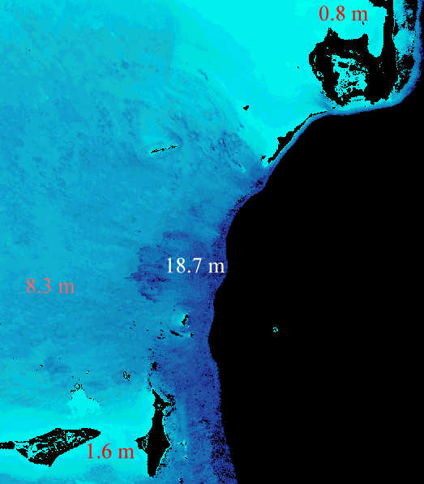
Representative image of the lesson:
Landsat image shows the modal depths

Lesson title: Compensating for Variable Water Depth to Improve Mapping of Underwater Habitats; Why It is Necessary
Module No. /Lesson No: M7/L5

Data key: CASI
Location: South Caicos, Turk and Caicos Island
Classification key: Bathymetry, coastal management
Connectivity: M5L5 & M7L4

Aim: To learn how to carry out “depth-invariant processing in order to compensate for the effect of light attenuation in the water column (i.e. water depth) on bottom reflectance using a CASI airborne image.

Location and Data: South Caicos, Turks and the Caicos island are the study area. CASI images at a spectral resolution of 1m in 2, 3, 4, and 5 wave bands are used for this purpose.

Procedure: The first step of the study is the inspection of image to see the effect of water depth on reflectance. For this CASI image of the green part of the spectrum may be displayed with stretching. A transect can be prepared in north south direction which shows the increase in depth. For the purpose of calculating deep-water radiance band 3 and 4 in the green part of the spectrum can be used. Images can be displayed with stretching. A rectangle of pixels can be selected at the mid bottom of each image where water is deepest and may be copied in to a spreadsheet to estimate the deepwater radiance. Deep-water radiance can be calculated from the deep-water mean and deepwater standard deviation.

As a next step selection can be done for pixels of uniform substratum with variable depth. Sand areas can be selected for this. The area may be chosen so that neither of the bands is saturated and both bands penetrate to the seabed. The selected area of both the images can be copied in to spreadsheet for estimating the ratio of attenuation of coefficient. Linearisation can be applied for the relationship between depth and radiance by taking natural logarithm. Ratio of attenuation of coefficients for the band pair may be conducted from the variance and covariance analysis.

This depth invariant processing will be removing the variation in reflectance that is due to water depth. After calculating the attenuation coefficients, the depth invariant algorithm can be implemented. For this a formula document may be prepared and applied to the connected images of band 3 and 4. To see how the effect of water depth has been compensated for in the depth invariant image, a transect line can be prepared which runs vertically down from the shallow water to deep water. Finally comparison can be conducted for raw image depth-invariant image.

Result: From the transect of the raw image it is seen that the depth has a profound effect on the reflectance as the habitat is largely Montastraea reef with bare substratum yet reef reflectance declines dramatically with depth along the transect.

In the dept invariant image there is no longer any trend of decreasing pixel reflectance depends on the habitat type with sand areas such as that at the south end of the transect having relatively high depth invariant index values. The structure of the reef front in deep water is clearly revealed and no longer does the image get darker as the water depth increases.

Schematic Representation of the lesson:
Step I

Display of the raw image to see the effect of the water depth on reflectance

Step II
Calculation of deep water radiance

Calculate the ratio of attenuation coefficients for band pair
Step III

Step IV

Generate the depth invariant index of bottom types for each band pair

Result
There is no longer any trend of decreasing pixel reflectance with increasing depth

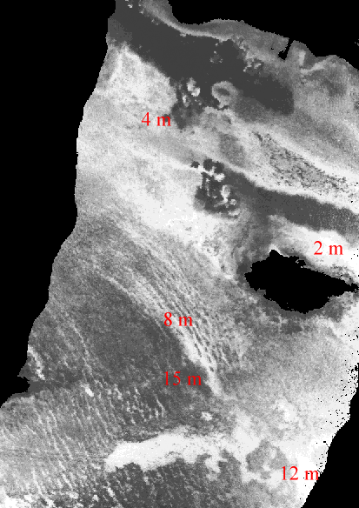
Representative image of the lesson:
Depth-invariant CASI image (attenuation due to depth removed)
Lesson title: Mapping the Major Inshore Marine Habitats of the Caicos Bank by Multispectral Classification Using Landsat TM
Module No. /Lesson No: M7/L6
Data key: Landsat 5 TM
Location: South Caicos
Classification key: Habitat, coastal management
Connectivity: M3L2, M6L2, M7L1 & M7L2

Aim: To undertake a supervised classification of a Landsat TM image to show the major marine and terrestrial habitat of the Caicos bank.

Location and Data: South Caicos Island area is the study area. Two depth invariant images produced from 1, 3 and 2, 3 bands of Landsat 5 TM taken on 22nd November 1990 and field survey data on seven habitat classes are taken for the study.

Procedure: Images may be displayed. The two depth invariant images may be masked for land by band 5 to highlight submerged areas using formula document. Submerged area may be classified into different classes using the spectral signature derived from the field survey data. Box classifier for each habitat may be created using the two depth invariant bottom index images. Classification may be improved by combining the overlapping classes. A formula may be applied to the connected image to produce 6 images, one for each habitat classes. Palette and stretch may be applied to visualize these classes clearly. These six images may be added together to get six classes in single image. More number of training sites may be used to adequately represent the habitat classes. Formula may be applied to the two depth invariant connected images and six new images each representing a habitat class may be created. The six images may also be added together and the different habitat may be clearly seen in the resultant image using palette. Filter may be applied and two classifications may be compared.

Result: The classes observed in the image are dense grass, sparse sea grass, sand, dense Montastraea reef, Gorgonian plain, Lobophora dominated algal areas and coral patch reef. On the basis of their depth invariant bottom index values, sand and sparse grass appear to be fairly separated from other classes, whilst there appears to be a lot of overlap in other classes. Because of the outline with relatively high depth invariant bottom index values in band 2-3, Gorgonian plain is likely to be confused with both Lobophora dominated algal areas and coral patch reefs. In the box classification and assigning colour, many habitats are seen but the classification is not complete, because the habitats are falling in to more than one class. In the image formed by adding 6 habitat class images much of the submerged area is unclassified, because the training sites do not adequately represent the habitat classes. Much more of the submerged classes are classified as greater number of training sites are used. Overlapping is avoided because the greater number of training sites has better sampled the spread feature space for each habitat.

Schematic Representation of the lesson:

Display of the images
Step I

Step II

Masking of the land

Box classification of submerged habitat using filed survey data
Step III

Step IV

Classification of habitat using twice the number of field survey points

Features like sparse sea grass, coral reef areas and sand are observed
Result

Representative image of the lesson:
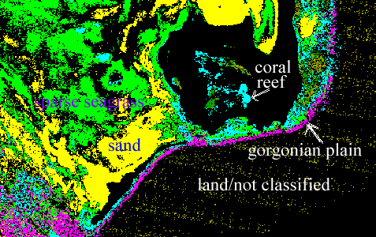Landsat image shows different habitats

Lesson title: Predicting Seagrass Standing Crop from the SPOT XS Satellite Imagery
Module No. /Lesson No: M7/L7
Data key: SPOT XS
Location: South Caicos
Classification key: Vegetation, coastal management
Connectivity: M3L3, M3L5, M4L1, M5L1, M5L2, M6L3, M7L1, M7L2 & M7L8

Aim: To learn how to derive a map of sea grass standing crop from a SPOT XS image

Location and Data: South Caicos is the study area. Depth invariant bottom index image of bands 1 & 2 of SPOT XS is used.

Procedure: Image may be displayed. Field data of selected sites may be related to the image data. A regression of sea grass standing crops on image data may be generated. Calibration may be implemented and at the same time land area in the image may be masked to highlight the submerged areas using formula document multiplying the depth invariant image by mask image. Another formula may be used to mask the non-sea grass areas in the resultant image. An output image with land set to zero and non-sea grass set to 255 and in between values indicating the sea grass standing crop may be produced. The number of pixels representing each class may be obtained using histogram option. Suitable palette may be applied to display the different classes of sea grass standing crop. The area of each class may be calculated by multiplying the number of pixel in those classes by the spatial resolution.

Result: The image shows the land boundaries, the standing crop of sea grass and the location of all other submerged habitats. After using calibration and land, non-sea grass mask, the sea grass standing crop classes are clearly seen in the image. Six sea grass classes are obtained which are according to their standing crop in g/sq. M They are, 1-5, 6-20, 21-70, 71-130, 131-200 and 201-254 g/sq. M and the area of standing crop is 353.1, 714.5, 437.5, 289.0, 82.9 and 7.2 respectively. A total of 2624.2 hectares of sea grass standing crop is calculated from the image.

Schematic Representation of the lesson:
Regression of the sea grass standing crop on the image using field survey data

Step I

Conversion of the pixel values to mean standing crop (g m⁻²)

Step II

Masking of the land and non sea grass area with a formula

Step III

Calculation of each sea grass class in hectares

Step IV

A total of 2624.2 hectares of sea grass standing crop is calculated from the image.

Result

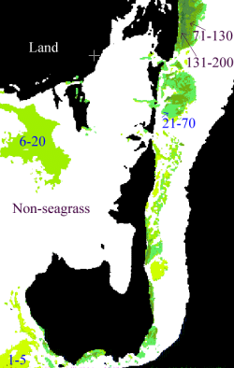
Representative image of the lesson:

SPOT XS image shows seagrass standing crop classes

Lesson title: Visual Interpretation of Images With the Help of Colour Composite: Getting to Know the Study area
Module No. /Lesson No: M7/L8

Data key: CASI
Location: South Caicos
Classification key: Vegetation, coastal management
Connectivity: M3L3, M3L5, M4L1, M5L1, M5L2, M6L3, M7L1, M7L2 & M7L7

Aim: To learn how to assess mangrove Leaf Are Index (LAI) using Compact Airborne Spectrographic Imager (CASI)

Location and Data: Data were collected at a spatial resolution of 1 sq. M in 8 wave bands during the flights over the Cockburn Harbour and Nigger Cay areas of the South Caicos, Turks and Caicos Island.

Procedure: As a first step NDVI image can be created from the band 6 and 7. These two images may be connected and a formula document containing an equation for the NDVI estimation can be applied. The resultant image may be saved. To establish a regression relationship that allows LAI to be predicted from NDVI the ground truth data may be used. In this LAI and corresponding NDVI of 30 ground points have been taken. For mapping LAI from NDVI regression of the LAI on NDVI can be carried out. For this intercept and slope can be estimated from the ground truth NDVI and LAI values. Since the graph of LAI against NDVI of ground truth data show maximum LAI of 10, it is possible to spread LAI measure over more of the display scale 0-255 by multiplying 10. This will mean that LAI values up to 2 will map to pixel values between 1 and 20 and so on. The saved image may be corrected with the new formula for the conversion of NDVI to LAI ([intercept + slope * @x] * 10). Palette can be applied to get more detail about the ranges of LAI. For calculating the proportion of this image area consists of mangrove of each LAI close histogram option can be used. Total area of the mangrove can also be found out. Once LAI is found out it is possible to find out net canopy photosynthesis production from LAI and it can be corrected to carbon produced per hectare per year.

Result: It is noted that mangrove areas with LAI greater than 8 are very rare. From the linear relationship between LAI and NDVI it is found that regression is very significant and NDVI is a good predictor of LAI. From the images it is estimated that approximately 635 tonnes of carbon annually are producing from this mangrove areas.

Schematic Representation of the lesson:

Creation of NDVI image from band 6 and 7
Step I

Mapping of LAI from CASI imagery using regression of LAI on NDVI

Step II

Estimation of net canopy photosynthesis production from LAI
Step III

Result

635 tonnes of carbon annually are produced from mangrove area

Representative image of the lesson:
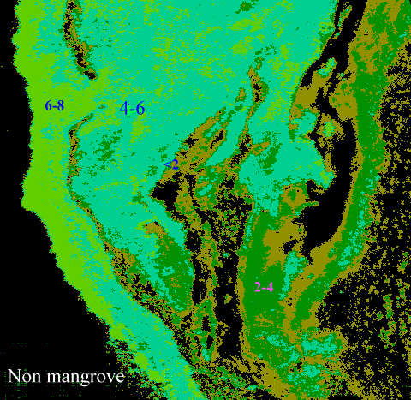
CASI image shows the Mangrove area with LAI ranges.

